**Smart Virtual Assistant**

Semester- VI

A PROJECT REPORT

*Submitted by*

**Hadiya Rajeshkumar Lakhabhai (140170107031)**

**Makwana Rudra Jayantbhai (140170107041)**

**Merchant Abid Ahmed (140170107044)**

***In fulfillment of the award of the degree***

***of***

**BACHELOR OF ENGINEERING**

**in**

**COMPUTER ENGINEERING**



**VISHWAKARMA GOVERNMENT ENGINEERING COLLEGE**

**CHANDKHEDA**

# Gujarat Technological University, Ahmedabad

May, 2018

**Candidate’s Declaration**

I/We hereby declare that project report titled “**PROJECT TITLE**” submitted towards the completion of project in 8th semester of Bachelor of Computer Engineering in Vishwakarma Government Engineering College, Chandkheda is an authenticate record of our work carried out.

I/We further declare to the best of our knowledge the report of C.E. 8th semester.

|  |  |  |
| --- | --- | --- |
| **Enrolment Number** | **Name** | **Sign** |
| 140170107031 | Hadiya Rajesh Lakhabhai |  |
| 140170107041 | Makwana Rudra Jayantbhai |  |
| 140170107044 | Merchant Abid Ahmed |  |

Vishwakarma Government Engineering

College, Chandkheda

Computer Department

CERTIFICATE



Date:

This is to certify that the project entitled Smart Virtual Assistant has been carried out by **Hadiya Rajeshkumar Lakhabhai (140170107031), Merchant Abid Ahmed(140170107044) and Makwana Rudra Jayantbhai(140170107041)** under my guidance in fulfilment of the degree of Bachelor of Engineering in Computer (8th Semester) of Gujarat Technological University, Ahmadabad during the academic year 2017-18.

Internal Guide Head of Department

Prof. Jalpa M Ramavat Prof M. T. Savaliya

Assistant Professor Associate Professor

VGEC Chandkheda VGEC Chandkheda

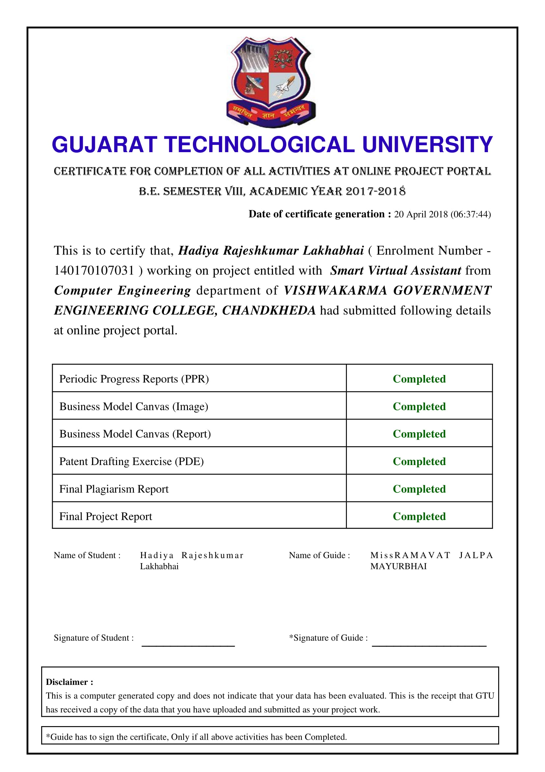

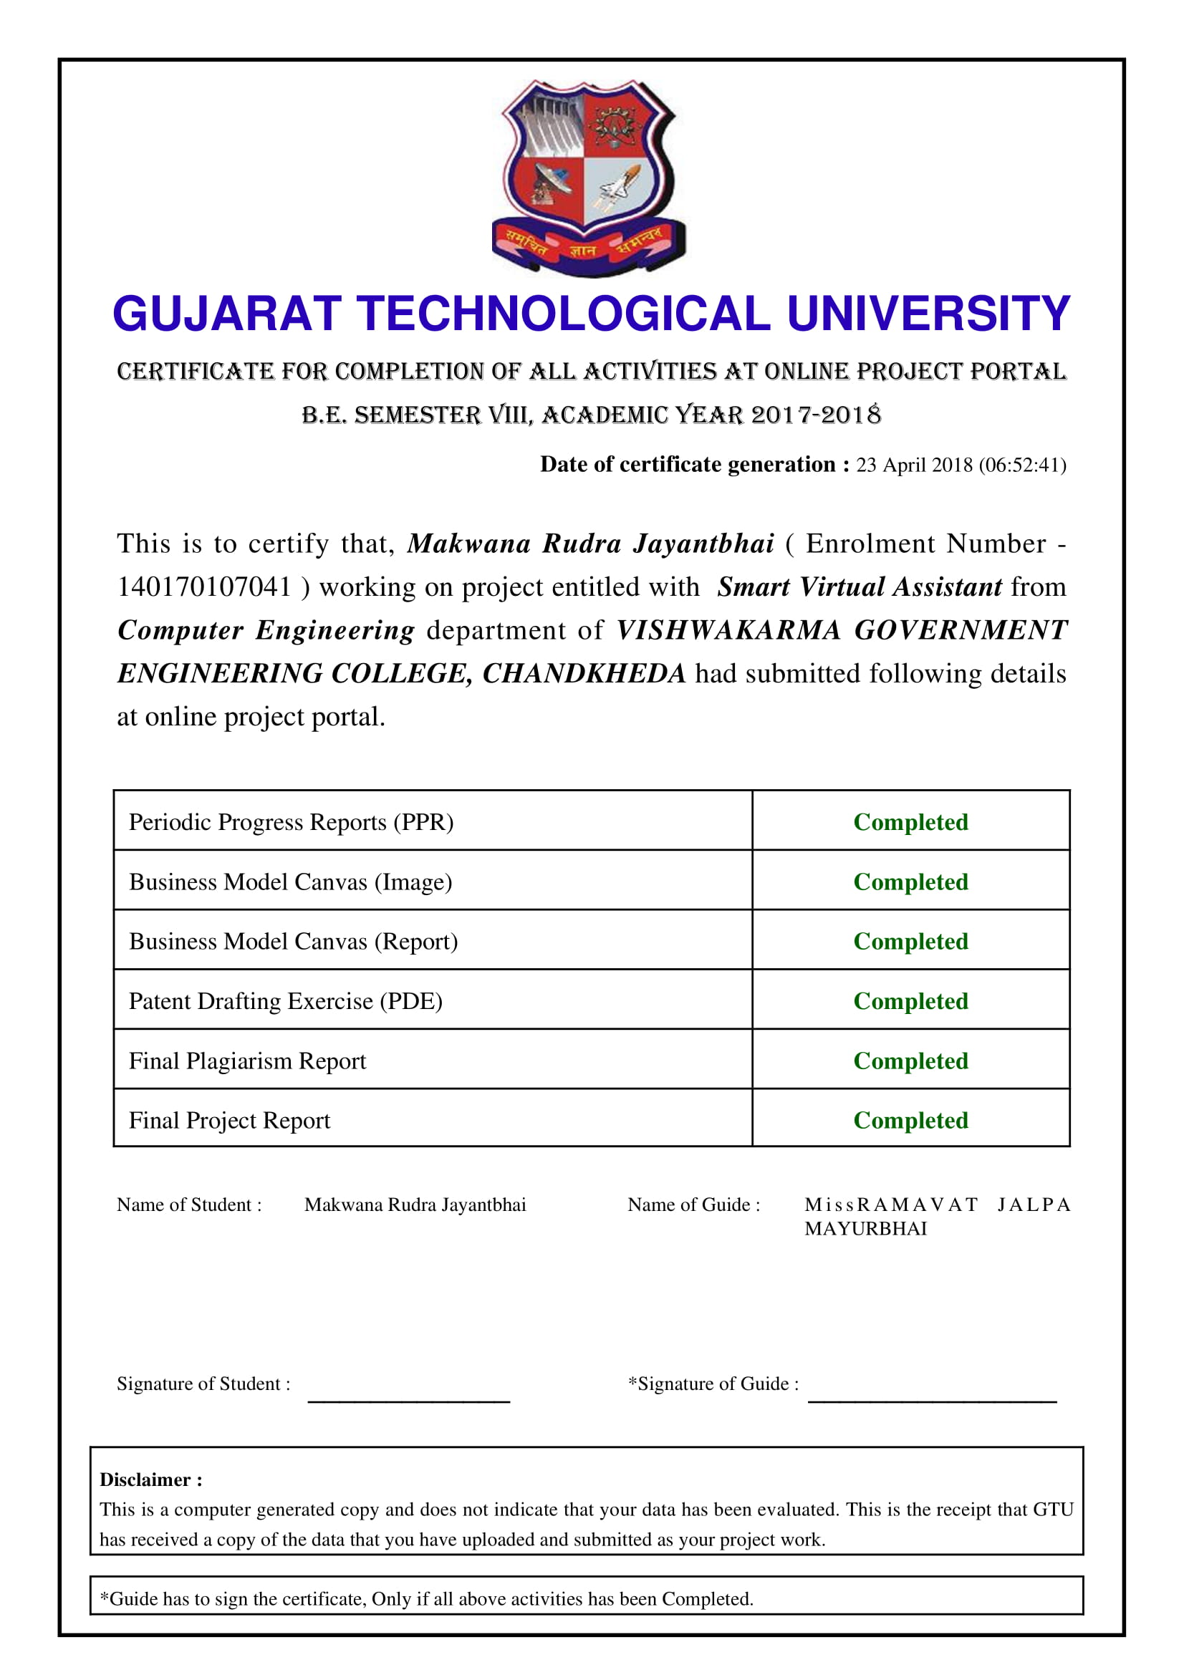

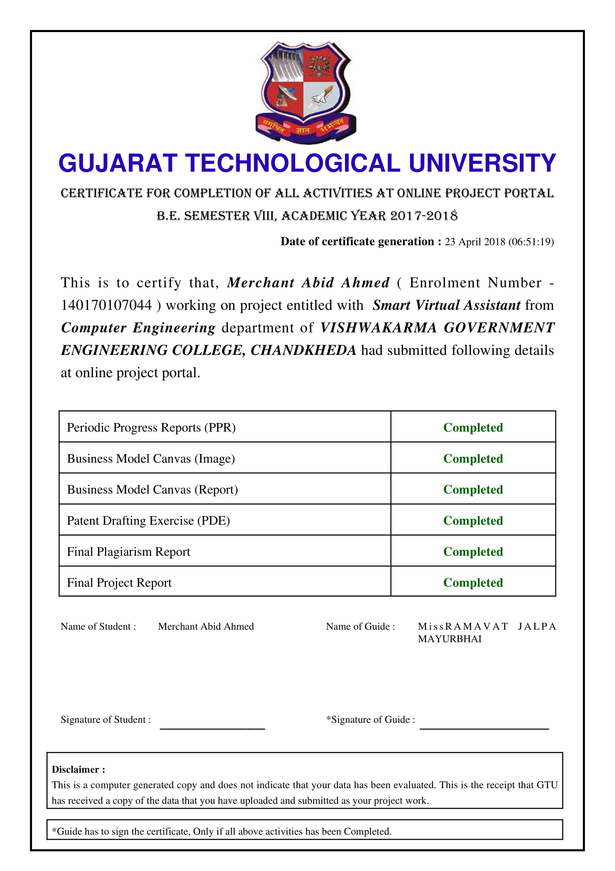

**Plagiarism Report**

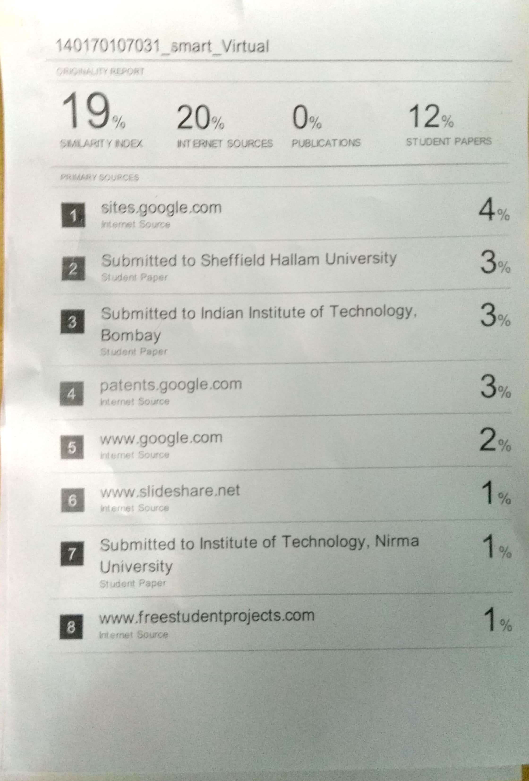

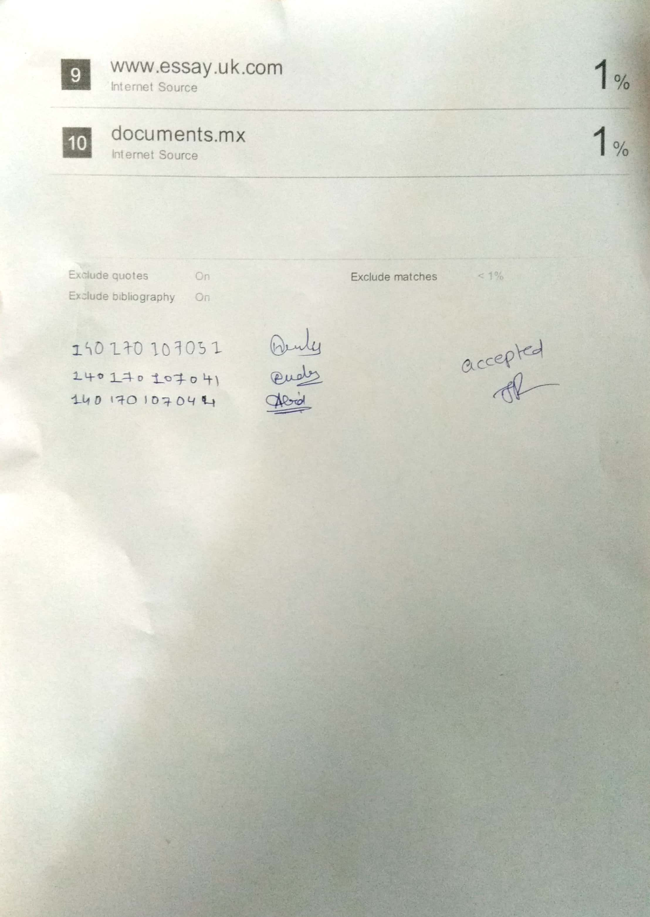

*ACKNOWLEDGEMENT*

*We would like to extend our hearty thanks with a deep sense of gratitude and respect to all those who has provided us immense help and guidance during our project.*

*We would like to express our sincere thanks to our internal guide Prof. Jalpa M Ramavat for providing a vision about the system and for giving us an opportunity to undertake such a great challenging and innovative work. We are grateful for the guidance, encouragement, understanding and insightful support given in the development process.*

*We would like to extend our gratitude to Prof. M.T. Savaliya, Head of Computer Engineering Department, Vishwakarma Government Engineering College, Chandkheda, for his continuous encouragement and motivation.*

*Last but not the least we would like to mention here that we are greatly indebted to each and everybody who has been associated with our project at any stage but whose name does not find a place in this acknowledgement.*

*Yours Sincerely,*

**Hadiya Rajeshkumar Lakhabhai (140170107031)**

**Makwana Rudra Jayantbhai (140170107041)**

**Merchant Abid Ahmed (140170107044)**

**Table of Contents**

|  |  |  |  |  |
| --- | --- | --- | --- | --- |
| **Abstract** | | | | **I** |
| **List of Figures** | | | | **Ii** |
|  |  | | |  |
| **Chapter 1.** | **Introduction** | | | **1** |
|  | 1.1 | Project Summary | | 1 |
|  | 1.2 | Purpose | | 2 |
|  | 1.3 | Scope | | 2 |
|  | 1.4 | Objective | | 3 |
|  | 1.5 | Technology and Literature Review | | 3 |
|  |  | | |  |
| **Chapter 2.** | **Project Management** | | | **4** |
|  | 2.1 | Project Planning | | 4 |
|  |  | 2.1.1 | Project Development Approach and Justification | 4 |
|  |  | 2.1.2 | Project Plan | 5 |
|  |  | 2.1.3 | Milestones and Deliverables | 6 |
|  |  | 2.1.4 | Roles and Responsibilities | 6 |
|  |  | 2.1.5 | Group Dependencies | 6 |
|  | 2.2 | Project Scheduling | | 6 |
|  | 2.3 | Risk Management | | 7 |
|  |  | 2.3.1 | Risk Identification | 7 |
|  |  | 2.3.2 | Risk Analysis | 7 |
|  |  | 2.3.3 | Risk Planning | 7 |
|  | 2.4 | Estimation | | 7 |
|  |  | 2.4.1 | Effort Estimation | 7 |
|  |  | 2.4.2 | Cost Analysis | 8 |
|  |  | | |  |
| **Chapter 3.** | **System Requirements Study** | | | **9** |
|  | 3.1 | User Characteristics | | 9 |
|  | 3.2 | Hardware and Software Requirements | | 9 |
|  | 3.3 | Constraints | | 10 |
|  |  | 3.3.1 | Regulatory Policies | 10 |
|  |  | 3.3.2 | Hardware Limitations | 10 |
|  |  | 3.3.3 | Interfaces to Other Applications | 10 |
|  |  | 3.3.4 | Parallel Operations | 10 |
|  |  | 3.3.5 | Higher Order Language Requirements | 10 |
|  |  | 3.3.6 | Reliability Requirements | 10 |
|  |  | 3.3.7 | Criticality of the Application | 11 |
|  |  | 3.3.8 | Safety and Security Consideration | 11 |
|  |  | 3.3.9 | Assumptions and Dependencies | 11 |
| **Chapter 4.** | **System Analysis** | | | **12** |
|  | 4.1 | Study of Current System | | 12 |
|  | 4.2 | Problem and Weaknesses of Current System | | 13 |
|  | 4.3 | Requirements of New System | | 13 |
|  |  | 4.3.1 | User Requirements | 13 |
|  |  | 4.3.2 | System Requirements | 14 |
|  | 4.4 | Feasibility Study | |  |
|  |  | 4.4.1 | Does the system contribute to the overall objectives of the organization? | 14 |
|  |  | 4.4.2 | Can the system be implemented using the current technology and within the given cost and schedule constraints? | 14 |
|  |  | 4.4.3 | Can the system be integrated with other systems which are already in place? | 15 |
|  | 4.5 | Requirements Validation | | 15 |
|  | 4.6 | Features of New System | | 15 |
|  | 4.7 | Use-case Diagram | | 16 |
|  | 4.8 | Class Diagram | | 17 |
|  | 4.9 | Sequence and Collaboration Diagram | | 18 |
|  | 4.10 | System Activity | | 19 |
|  |  |  | |  |
| **Chapter 5.** | **System Design** | | | **20** |
|  | 5.1 | Package Diagram | | 20 |
|  | 5.2 | Component and Development Diagram | | 20 |
|  | 5.3 | System Application Design | | 22 |
|  |  | 5.3.1 | Method Pseudo code | 22 |
|  | 5.4 | Input/output and Interface Design | | 24 |
|  |  | 5.4.1 | State Transition/UML Diagram | 24 |
|  |  | 5.4.2 | Samples of Forms, Reports and Interface | 25 |
|  |  |  | |  |
| **Chapter 6.** | **Implementation Planning** | | | 28 |
|  | 6.1 | Implementation Environment | | 28 |
|  | 6.2 | Program/Modules Specification | | 28 |
|  | 6.3 | Security Features | | 28 |
|  | 6.4 | Coding Standards | | 28 |
|  |  |  | |  |
| **Chapter 7.** | **Testing** | | | 29 |
|  | 7.1 | Testing Plan | | 29 |
|  | 7.2 | Testing Strategy | | 29 |
|  | 7.3 | Testing Method | | 29 |
|  | 7.4 | Test Cases | | 29 |
|  |  | 7.4.1 | Purpose | 29 |
|  |  | 7.4.2 | Required Input | 30 |
|  |  | 7.4.3 | Expected Result | 30 |
|  |  |  | |  |
| **Chapter 8.** | **Limitation and Future Enhancement** | | | 31 |
|  |  |  | |  |
| **Chapter 9.** | **Conclusion and Discussion** | | | 32 |
|  | 9.1 | Self-Analysis of Project Viabilities | | 32 |
|  | 9.2 | Problem Encountered and Possible Solutions | | 32 |
|  | 9.3 | Summary of Project work | | 32 |
|  |  |  | |  |
| **References** | | | | **33** |
| **Appendix** | | | | **34** |

*ABSTRACT*

*Smart Virtual assistant is capable of understanding human language and then respond to it in different ways. Virtual Assistant will be able to do basic tasks like opening mobile applications, opening services like wifi/hotspot, making notes, setting reminders/alarms, navigation, scheduling of user’s activities, notifying for various meeting/events etc. It is also capable of responding to user’s questions which can be on any topic, these types of questions would be replied by Assistant by searching on the Internet for appropriate answer, for this Machine Learning algorithms will be used. So, our Virtual Assistant will be there for user in every situation. User can ask a query to assistant by speech/text which will be taken as an input string by the application.Response by the assistant can be in the form of some action, speech response, graphical representation of some result or in the form of text, this depends of the type of query user had spoken.*

List of Figures

|  |  |  |
| --- | --- | --- |
| **Figure No.** | **Figure Name** | **Page No.** |
| 2.1.1.1 | Incremental Model | 4 |
| 4.7.1 | Use Case Diagram | 16 |
| 4.8.1 | Class Diagram | 17 |
| 4.9.1 | Sequence Diagram | 18 |
| 4.10.1 | Activity Diagram | 19 |
| 5.1.1 | Package Diagram | 20 |
| 5.2.1 | Component Diagram | 20 |
| 5.2.2 | Deployment Diagram | 21 |
| 5.3.1.1 | Code Screenshot | 22 |
| 5.3.1.2 | Regex Code | 22 |
| 5.3.1.3 | Code Screenshot-2 | 23 |
| 5.4.1.1 | State Diagram | 24 |
| 5.4.2.1 | App Interface (Off) | 25 |
| 5.4.2.2 | App Interface (On) | 26 |
| 5.4.2.3 | App Interface (Input) | 27 |
|  |  |  |

**Chapter-1: Project Summary and Introduction**

* 1. **Introduction:**

People nowadays are getting busier and busier and everyone wants that there should be some entity that keeps track of their schedules, reminds them for their meetings, events and helps them manage and perform their day- to-day activities.

So, our Smart Virtual Assistant is a solution to all such types of demand on a single platform. It can perform basic tasks such as opening your Whatsapp/Camera or any other services like wifi, hotspot to many complex tasks like responding to user’s queries and questions and understanding human’s natural language and giving response according to it, Navigating to destiny.

The concept behind the project was to make a complete Assistant, so we have included the feature that the Assistant will give response to user in Text, Voice so as to make user as comfortable as possible. So as a whole, this Assistant will make user feel as if it’s mobile is his own personal Assistant who is there for him in every situation.

**Summary:**

Our project is about a Virtual Assistant who is smart enough to understand human’s Natural Language. It’s response can be divided into two parts according to types of queries such as:

1. Action
2. Question

If a user’s query demands for an action, then assistant will directly perform that task, for example if user speaks “Open Whatsapp”, then assistant will open whatsapp. These types of queries and bounded queries mean they don’t need any further interaction.

Second type of query includes a question, in this type user asks assistant a question and in return expects an answer. For example, user questions “Who is Prime Minister of India” then assistant will respond as “Narendra Modi”, these types of questions will be unbounded so in this case user may again ask further question relevant to above question.

Apart from these, assistant will be able to perform tasks like Navigation, News Updates, Interaction, Suggestions related to user etc.

* 1. **Purpose**

Purpose of our application is to provide seamless interaction of user and Mobile device through voice communication. This will help user in increasing its efficiency in its task by scheduling it and also it will save him/her a lot of time. Moreover controlling of application will be based on speech so handicapped person can also take its advantage.

* 1. **Scope**

Scope of our project is to provide seamless interaction between user and his/her mobile device. User can be able to perform basic tasks like calling a contact, setting a reminder, opening apps and services. Moreover, user will be able to search any information on Internet just by asking it to assistant. For performing all these tasks, input by user will be given by speech.

* 1. **Objective**

The objective of our project is:

1. Assisting user to manage his/her Android mobile device with speech and to respond to his questions which might cover topics related to latest news.
2. Assistant would be capable to manage user’s mobile and also would be capable to schedule his events, give notifications for various tasks and to suggest some good practices that needs to be given user’s attention.

If a mobile is not compatible with his Android device, then assistant will be a great help for him as he didn’t have to search his mobile for everything he want his device to perform

* 1. **Technology and Literature Survey**

For learning about Android Development we referred to its official website. We understood working of RNN from Stanford’s lectures. There were many APIs available for Natural Language Processing tasks like Stanford’s CoreNLP, Python’s NLP library, Watson API, Wolfram API. So, we compared the working and efficiency of those APIs and finally chose Wolfram API to work with. Now, we are using Wolfram API for NLP related task and “Action” based queries are handled using regular expression rules.

**Chapter-2: Project Management**

* 1. **Project Planning**
     1. **Project Development Approach and Justification**

**Incremental Model:**

* Incremental model was the most appropriate development approach for our project, as in this model first requirements are analyzed the further steps according to Waterfall model are undertaken.
* As given in figure, initially first increment is made and released so user can use it, then again different releases are made and then are included in the existing system.

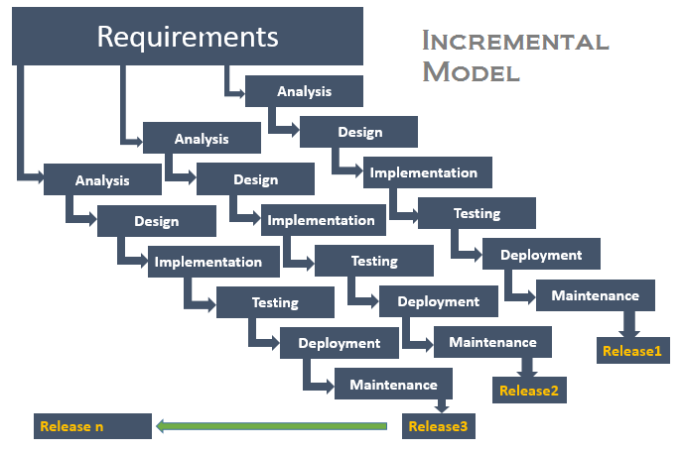

Figure 2.1.1.1 Incremental Mode

**Advantages:**

* It is easier to make initial easy components rather then make whole project simultaneously.
* Coding defects in the above increments can be removed in the upcoming increments.
* Easier to maintain.
* Working application is ready at early stage as user will get application for use from the very first increment.

**Disadvantages:**

* If components of earlier increments overlap the components of new increments, then it would be very tough to assemble them and do the testing part.
* If testing is not done properly at earlier increments, then its effect will last in all the upcoming increments.
  + 1. **Project Plan**

Project planning is one of the most important part of the project, if the planning is not perfect than the effect will last till end results. So, our team specially gave greater importance to the planning part.

After finalizing the project definition, we started to gather all the relevant information by searching on Internet, approached to our faculties for suggestions regarding our project and took tips from various working professionals in this field.

Then as per our planning, we divided our work and started to upgrade our knowledge in that area by joining online courses of websites like Coursera or by studying various topics relevant to our subject on youtube or other websites. Then we started to develop smaller components and then tested for it’s accuracy.

Finally, we completed all the tasks and then tested our project

* + 1. **Milestones and Deliverables**

We tried to reach every Milestone that we thought at the beginning, some of them were not feasible in limited time frame, so we were not able to do that. Key deliverables of our application are we were able to develop Regex rules for “Action” based queries and then mix it with NLP Api for “Question” based queries.

* + 1. **Roles and Responsibilities**

We divided Roles and Responsibilities equally among our group members and then started our work. Some of the important and notable tasks to be completed was to develop UI, develop Regex rules and to add Api in our project and synchronize it with our rules.

* + 1. **Group Dependencies**

For performing NLP tasks we are heavily dependent on the NLP tool that we are using, even though we were cautious in using the accurate tool, some errors might occur during processing.

* 1. **Project Scheduling**

We scheduled our project so that we complete it on time. We scheduled that during our 7th semester we will analyse all the market products related to our project and study about our technology. Then, in 8th semester we started designing our project and now we are on the verge of completing our product on time as scheduled.

* 1. **Risk Management**
     1. **Risk Identification (it is concerned with discovering possible risk to the project)**

Our project is mainly based on accuracy of our NLP tool and accuracy of our Regex rules; if the user query is obscure or ambiguous then application will not be able to handle the query. Some other risks are user is bound to speak English language only, Android device is compulsory, if Internet is not working properly results will be given lately etc.

* + 1. **Risk Analysis(each identified risk is considered in turn and a judgment made about the probability and the seriousness of the risk)**

Probability of user not knowing English language is less. Speed of internet depends on location and availability of internet in that area, so this risk will be lesser in Big cities and more in small towns.

* + 1. **Risk Planning (Identify strategies to manage the risk)**

To handle above mentioned risks we have taken some precautions like we will be dealing with most types of queries offline to give speedy results. If the query is not properly understood by application it will notify the user for its mistake and will ask for new instructions. We have tried our best to use good Algorithms for faster reply of user queries.

* 1. **Estimation**
     1. **Effort Estimation**

Our main efforts would be used in making an android application base on which we can then add features of our project. Firstly, we developed our Android application for basic queries like opening assistant, and then we added more features and finally added NLP Api for Natural Language Processing tasks. So, we were finally able to make our complete project work smoothly.

* + 1. **Cost Analysis**

As our project does not have any specialized hardware tool, cost of our project is very low. Main cost was the NLP Api we will be using in our project. As some of them were paid, we chose the one which was open source so we do not have to pay for that and moreover we also took care that efficiency was not compromised. Android Development software are free of cost, so overall no cost was barred by us in using Software. But some hidden costs were there like planning of our project, but they were negligible.

**Chapter-3: System Requirement Study**

**3.1 User Characteristics**

Types of users that would be dealing with our application are the people who want to get quick access to any information from Internet can use our application and get information on their tips only by asking it to assistant through voice medium.

Some users will be using our application just to manage their mobile through voice in order to save some time and also to increase efficiency as basic tasks like calling, setting reminders, messaging etc will be done quickly by application itself. So, there will be various types of users who will be using our application in their day-to-day life.

**3.2 Hardware and Software Requirements**

To run any application there are some basic requirements that should be attained in order to run that application as it was designed to be. Hardware and Software requirements of our project are given below:

**Hardware Requirements:**

Hardware requirements are listed below:

* Android Device
* Speech Recorder working smoothly
* Speaker should work finely

**Software Requirements:**

Software requirements are listed below:

* Internet is necessary
* RAM : 1GB

**3.3 Constraints**

**3.3.1 Regulatory Policies**

User has to speak English language compulsory in accent in which application understands or application might not be able to understand and process it.

**3.3.2 Hardware Limitations**

Hardware Limitations are that mobile device’s audio recorder and speaker should work accurately for interaction between user and device.

**3.3.3 Interfaces to Other Applications**

We will be using Internet to search information on internet, so connectivity to internet is a necessity. Moreover, our application will be opening different services and applications as instructed by user.

**3.3.4 Parallel Operations**

After getting input string, string will be analysed and then if some information is to searched on internet, it will be searched on internet along with generating a response to user.

**3.3.5 Higher Order Language Requirements**

Higher order Language is required to perform Natural Language processing tasks and to make an attractive User Interface for our application.

**3.3.6 Reliability Requirements**

For our application to be reliable, accuracy of analysing input string is very important aspect. Other requirements are Internet connectivity must be there.

**3.3.7 Criticality of the Application**

Application will be very helpful to users who want to search any information on Internet and for students who want to browse any topics for net and professionals who want to there mobile device to open application/service as inquired by him.

**3.3.8 Safety and Security Consideration**

We will be using mobile’s Internet, so at installation time we will be informing using about this thing for security purpose. If user is inquired to give any personal information, we will display it anywhere and will be safe.

**3.3.9 Assumption and Dependencies**

We are dependent on the mobile device for taking input string, so we assume that the device must be an Android device. We assume that Internet connection is available and working smoothly and user knows English language in the accent the application understands.

**Chapter-4: System Analysis**

**4.1 Study of Current System**

Nowadays, there are many digital assistant is available in market like Google Assistant, Microsoft Cortana, Apple Siri, Samsung Bixby, Lyra and lot more. They belonged to different mobile platforms. They share one common task: Enable user to manage and control his/her device with speech rather than touch. Additionally, they help user to do routine task easily through speech like providing navigation on map, set reminder, provide information of weather, launching apps, calling/texting other users, answer to user's questions and many more things.

**How does a digital assistant work?**

Currently, all major digital assistants are based on client-server architecture. They works as follow:

* Speech Recognition: First of all, an underlying Speech Recognition engine recognize what user spoke and convert the speech signals get converted into text using Speech to text Engine.
* Sending data to server: The text data is then send to server for further processing of data. A program residing on server analyze the data and decide whether user speak about action or question. If action is found, server sends appropriate commands to trigger specified action. If a question is found, server tries to find the answer and sent relevant data to client.
* Interaction with user: Client app get the data from server and process further if needed. Then notify user about results in spoken form.

**4.2 Problems and Weaknesses of Current System**

**1. Internet Connection is required**

Currently all major digital assistant required connection to internet to communicate with server. Sometimes this is less efficient, because there are some actions which can be performed directly on device like calling/texting other users, launching apps etc and it does not required internet connection. Thus current digital assistant is less useful if user does not have active internet connection.

**2. More battery consumption**

Battery Consumption is serious issue because mobile devices as designed to operate on low power battery. Some of these assistants are battery consuming, because connecting to internet each time is time and resources consuming process which in turn increase load on battery and consume more battery power.

**3. Unable to recognize context**

Some of these assistants are not able to recognize the context of speech of user. For example if user asked one question, and then ask another follow up questions, assistants are not able to understand the relation between two questions

**4.3 Requirements of New System**

**4.3.1 User Requirements**

* **No Internet Needed for basic Actions**: One of the big benefits is there is no internet connection is needed for performing basic actions on device. Basic actions are parsed and performed on devices without connecting to internet.
* **Less Battery Consumption**-As there is no internet needed for basic actions, battery consumption by this system is less compared to other apps.

**4.3.2 System Requirements**

We tried to compare different NLP tools and have used the best possible tool, so the system works efficiently. Moreover, some other benefits are we will be performing analysis of some basic queries offline to reduce the use of Internet.

**4.4 Feasibility Study**

This topic highlights the feasibility of our project.

**4.4.1 Does the system contribute to the overall objectives of the organization?**

We have developed our system according to our objectives that we thought at the start of our project. The basic contribution of our project was to provide seamless interaction between user and mobile device which we have achieved at the end of the project. However, the accuracy of the system may depend on the type of user operating it, as the English accent system understand might be different from user’s accent.

* + 1. **Can the system be implemented using the current technology and within the given cost and schedule constraints?**

Yes, the system can be implemented using the current technologies that are available in the market. But, the accuracy of NLP tasks are not yet 100% but still the working accuracy is near to 100% and the user will not fell any glitches while using our system.

* + 1. **Can the system be integrated with other systems which are already in place?**

As we have mentioned before that there are many systems already available in the market and they use their own algorithms to perform their tasks. So, to integrate our system with other systems, first we have to check whether the other system is compatible with our system or not.

* 1. **Requirements Validation**

Our main objective for making this project was to provide seamless interaction between user and mobile device and we think that we have quite successfully achieved it as our system is capable of doing in quite accurately. So, mostly all our requirements are fulfilled.

* 1. **Features of the New System**

Features of our system are listed below:

* Voice Interaction
* Quick Response
* Searching Information on Internet
* Performing given task
* Calling a contact
  1. **Use Case Diagram**

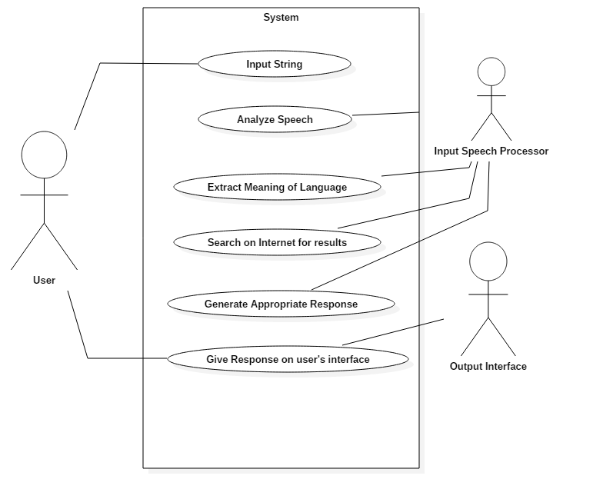

Figure 4.7.1 Use Case Diagram

* 1. **Class Diagram**

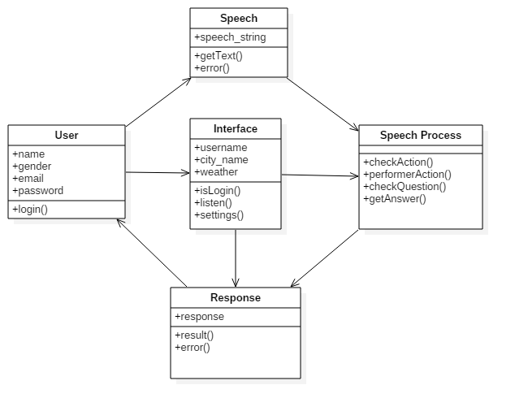

Figure 4.8.1 Class Diagram

* 1. **Sequence and Collaboration Diagram**

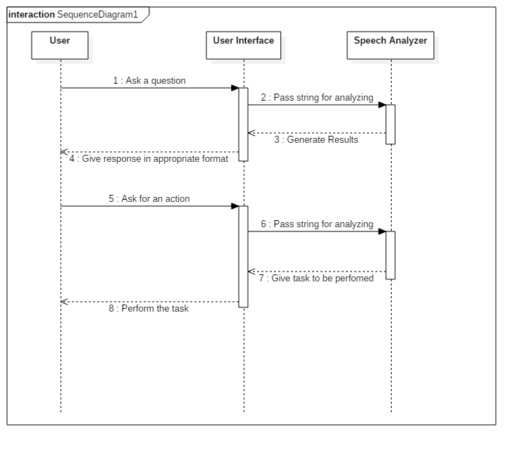

Figure 4.9.1 Sequence Diagram

* 1. **System Activity**

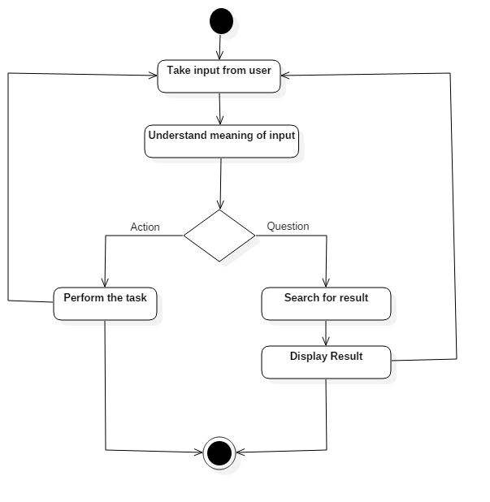

Figure 4.10.1 Activity Diagram

**Chapter-5: System Design**

**5.1 Package Diagram**

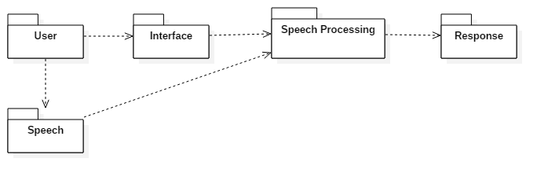

Figure 5.1.1 Package Diagram

**5.2 Component and Deployment Diagram**

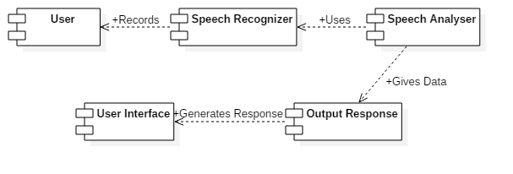

Figure 5.2.1 Component Diagram

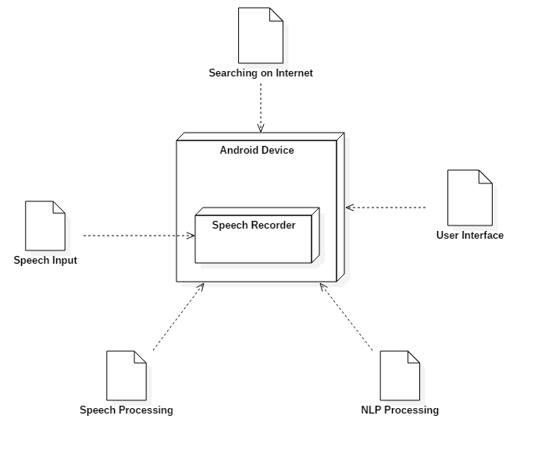

Figure 5.2.2 Deployment Diagram

**5.3 System Application Design**

**5.3.1 Method Pseudo Code**

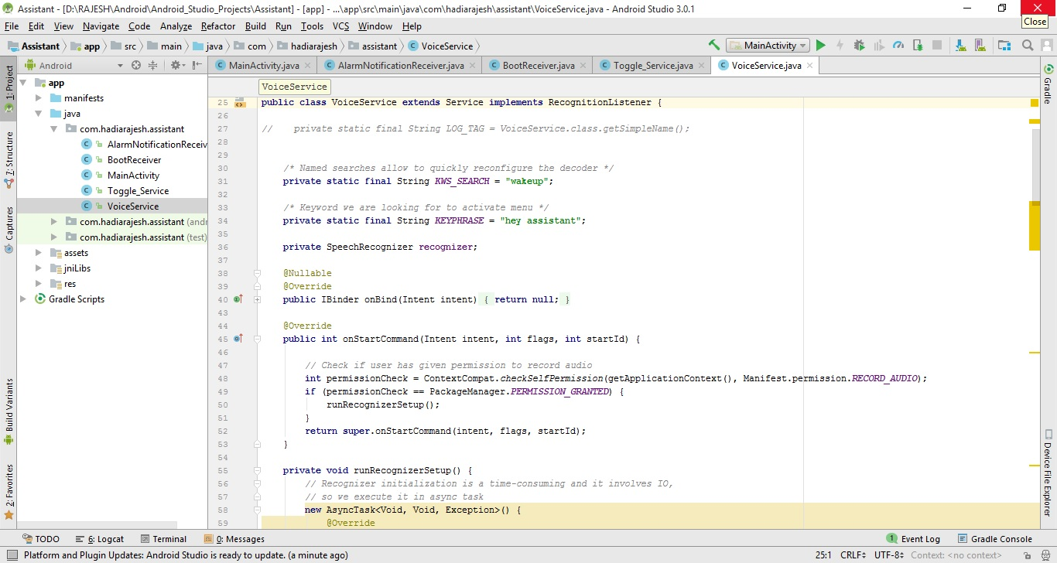

Figure 5.3.1.1 Code Screenshot

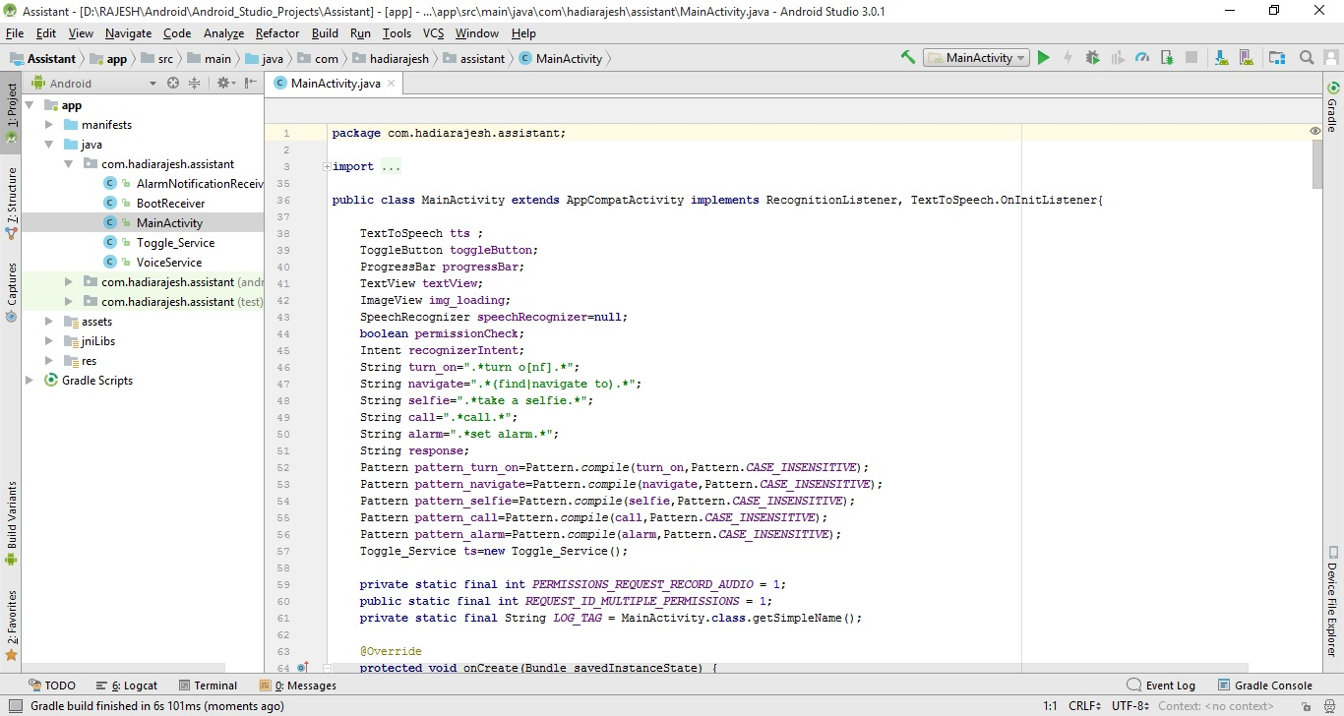

Figure 5.3.1.2 Regex Code

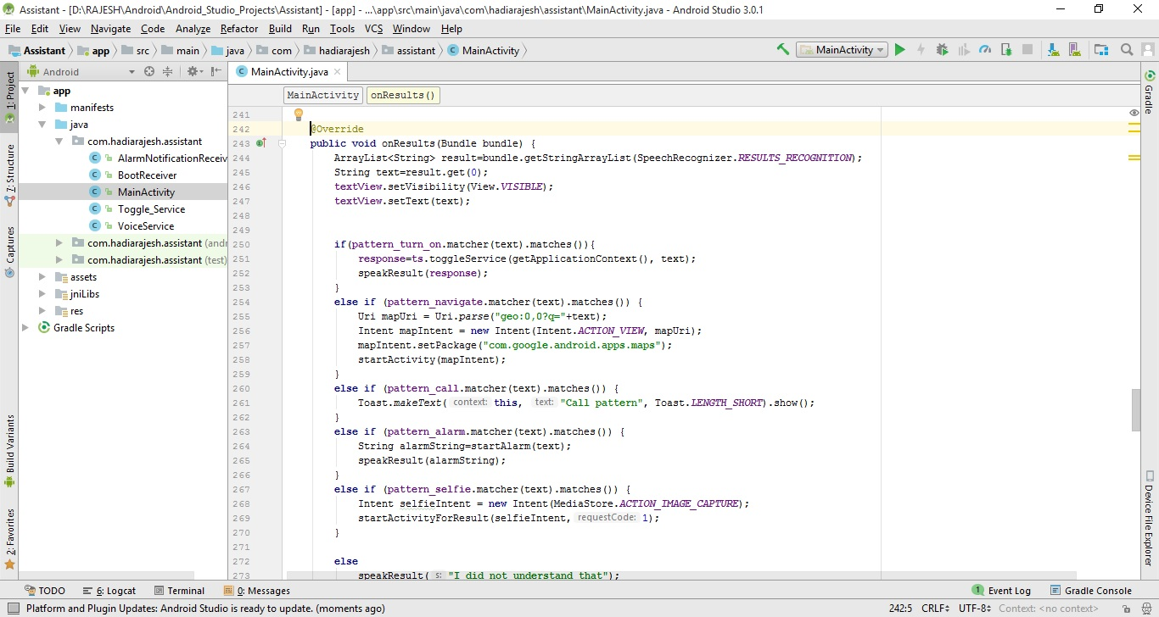

Figure 5.3.1.3 Code Screenshot-2

**5.4 Input/Output and Interface Design**

**5.4.1 State Transition/UML Diagram**

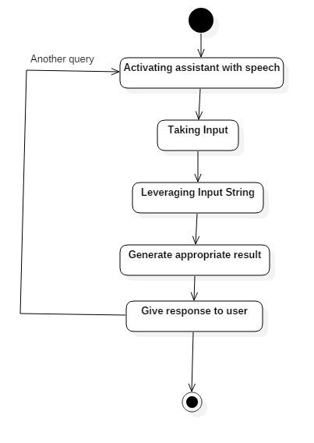

Figure 5.4.1.1 State Diagram

**5.4.2 Samples of Forms, Reports and Interface**

Screenshot of interface of our application are given below. It includes states when application is listening, not listening and input string is taken.

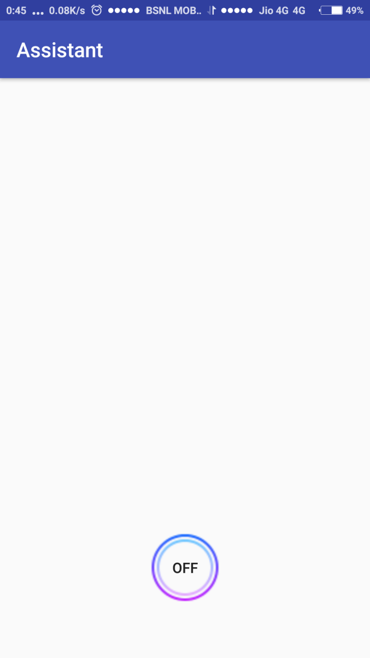

Figure 5.4.2.1 App Interface (off)

When application is not listening.

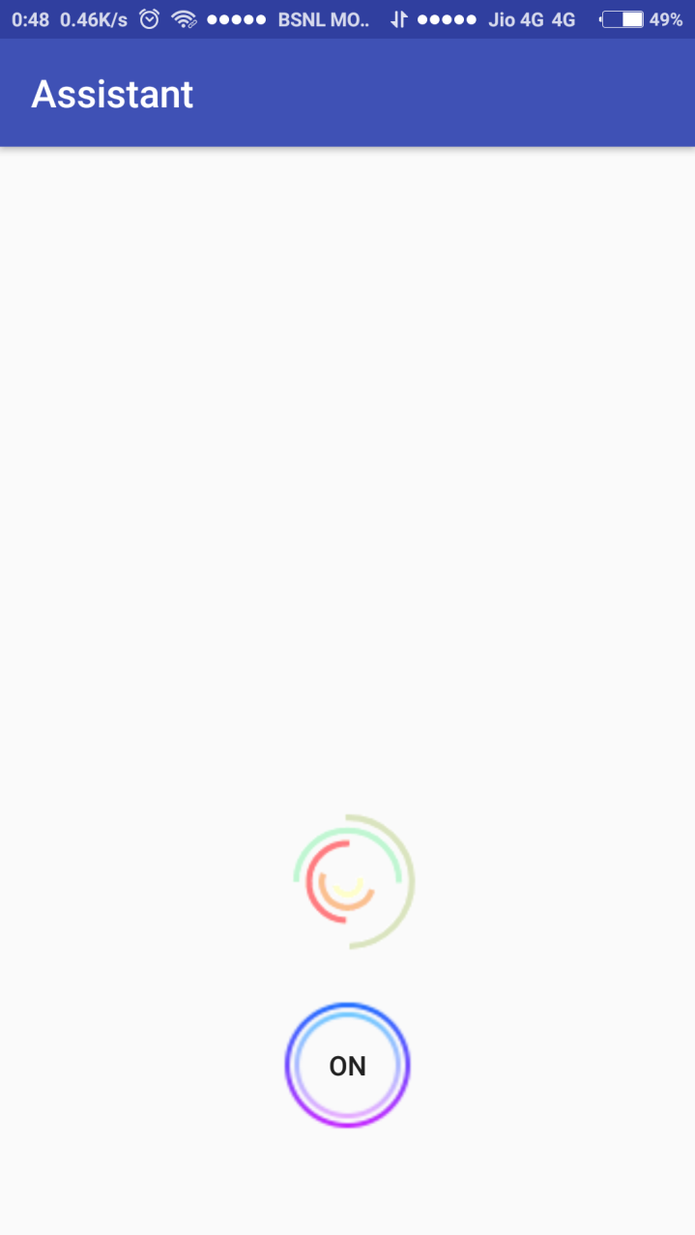

Figure 5.4.2.2 App Interface (On)

When application is listening to user’s instruction and trying to get string input through speech.

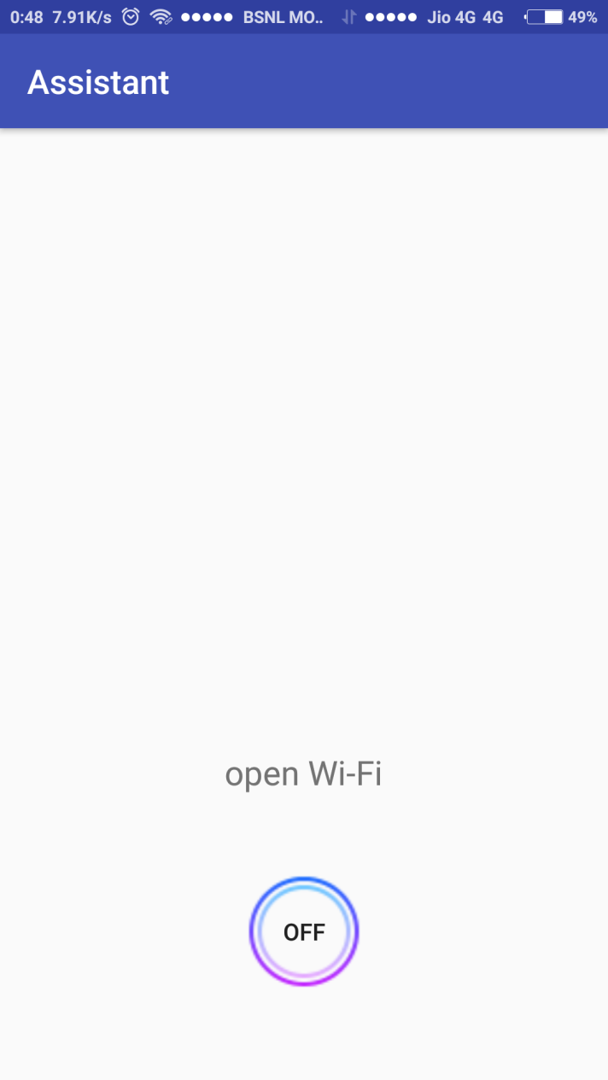

Figure 5.4.2.3 App Interface (Input)

Application has taken input as displayed on the screen. This input String will now be analysed and an appropriate response will be given to user.

**Chapter-6: Implementation Planning**

**6.1 Implementation Environment**

We are using Android Studio to develop Smart Virtual Assistant android app using Windows platform. We are using java programming language to develop app. We are using JDK 9.0.1 and Android studio 3.0.0 at the time.

**6.2 Programs/Module Specification**

By use of speech:

* Ability to control device by toggling services Wi-Fi, Bluetooth etc.
* Ability to call and message to specified contacts
* Ability to set alarms and reminders
* Ability to take pictures
* Ability to find and navigate places
* Ability to answer general questions of user

**6.3 Security Features**

To provide security we will be not showing the algorithm and implementation of our backend tasks to user and only the response will be shown to user. User’s data is also important for us, so we will also save any details taken securely.

**6.4 Coding Standards**

We have followed below coding standards in our project.

* File name must be same as class name as we have used Java (android).
* Every method included in a class contain a comment that lists various information like attributes, post condition, pre condition, @param, @return and requirement number.
* Lines are not longer than 80 characters as it is not supported by some tools.
* Comments are given whenever there is a chance that the code may be ambiguous when read by any other team member.
* One variable declaration per line.
* Blank spaces are given wherever necessary.

**Chapter-7: Testing**

**7.1 Testing Plan**

Our plan for testing was to check the accuracy of our NLP tool and whether our Regex rules are working as per the task is assigned.

So, we firstly entered String of types “Action” to check the efficiency of the Regex rules. They were working pretty good. Then, we entered “Question” type of query to check the correctness of the obtained result and that too worked properly.

**7.2 Testing Strategy**

As explained before, we have divided the testing in two parts. So, our strategy was to develop test cases for both the scenarios and to test project as extensively as possible.

**7.3 Testing Methods**

We have used Unit Testing and Regression Testing methods to test our project. We tested our project after each unit was developed and when those units were assembled, we tested it again. At last, we tested whole project. Also, we tested our project for worst input to check how it gives response in garbage input.

**7.4 Test Cases**

**7.4.1 Purpose**

Purpose for test cases is to check how the project works in different conditions and whether desired output is obtained or not.

**7.4.2 Required Input**

Required input was that the input string must be generated same as what user speaks. Input string might be of the type “Open Whatsapp” or “Call Abid” etc.

**7.4.3 Expected Result**

Expected result after getting the input string would be that application will do the task what user have inquired for or the correct information will be provided by application as what was asked by user to application.

**Chapter-8: Limitation and Future Enhancement**

**Limitation:-**

1. **Difficulty with Different Accent:-**

Different people have different English accents and it creates ambiguity for machines. It is very difficult to make Natural Language Processing(NLP)that can deal with different accents. It is hard because it takes too much time to be created and also takes a lot of storage as if made for different accent.

1. **Android Device must be needed:-**

Smart Virtual Assistant can only work on Android Device as it is an android application.

1. **Internet needed for some tasks:-**

Our application does some tasks that require internet connection. Some tasks like searching some info like “WHO IS THE PRIME MINISTER OF INDIA?”. It is not possible to provide such info without internet so device is must have to be connected with internet.

1. **Conflicts due to Google Assistant:-**

Some users have Google Assistant installed on their Android devices. Google Assistant is an in-built application which must be stopped as it also uses mic in background. Because of two device is using mic in background it should create confliction between them.

**Future Enhancement:-**

* We will try to enhance our application that is we are using. So different accents should be understood by our application.
* We will also try to make great UI for users that they don’t feel difficult while using our application.
* After getting feedback and reviews, we will try to provide new features and more efficiency.

**Chapter-9: Conclusion and Discussion**

**9.1 Self Analysis of Project Viabilities**

* In this modern world, users want to use their devices with less efforts. So Smart Virtual Assistant helps user to use device with less effort as it is voice/speech controlled. We have analysed the possible probability of success of our project and we have found it is possible to achieve most of our goals or features of our application.

**9.2 Problem Encountered and Possible Solutions**

* We have encounters many problems while developing an application such as it is not easy to find NLP API for our application. It took much effort than we have thought.
* Our application consists of too much tasks which is difficult create together by one person. So we have divided all the tasks into modules and developed modules independently. This made a lot easier to develop an application.

**9.3 Summary of Project Work**

* In the 7th semester, we made different types of design canvases related to our project. We have also generated plagiarism reports. And then we have done work on patent. We have also scheduled our tasks how to develop an application. We have also decided which team member will do which tasks.
* In the 8th semester, we all worked as we have decided and scheduled previous. We have developed our application module manner means we developed different modules and then combined those in one application. After that we have started testing for checking that each modules are working well or not together.

**References**

1. <http://testingfreak.com/incremental-model-software-testing-advantages-disadvantages-incremental-model/>
2. <https://www.guru99.com/testing-methodology.html#4>
3. <https://www.android.com/>
4. <https://en.wikipedia.org/wiki/Wolfram_Alpha>
5. <http://products.wolframalpha.com/api/>
6. <https://developer.android.com/reference/java/util/regex/Pattern.html>

**Appendix**

**PPR1(044)**

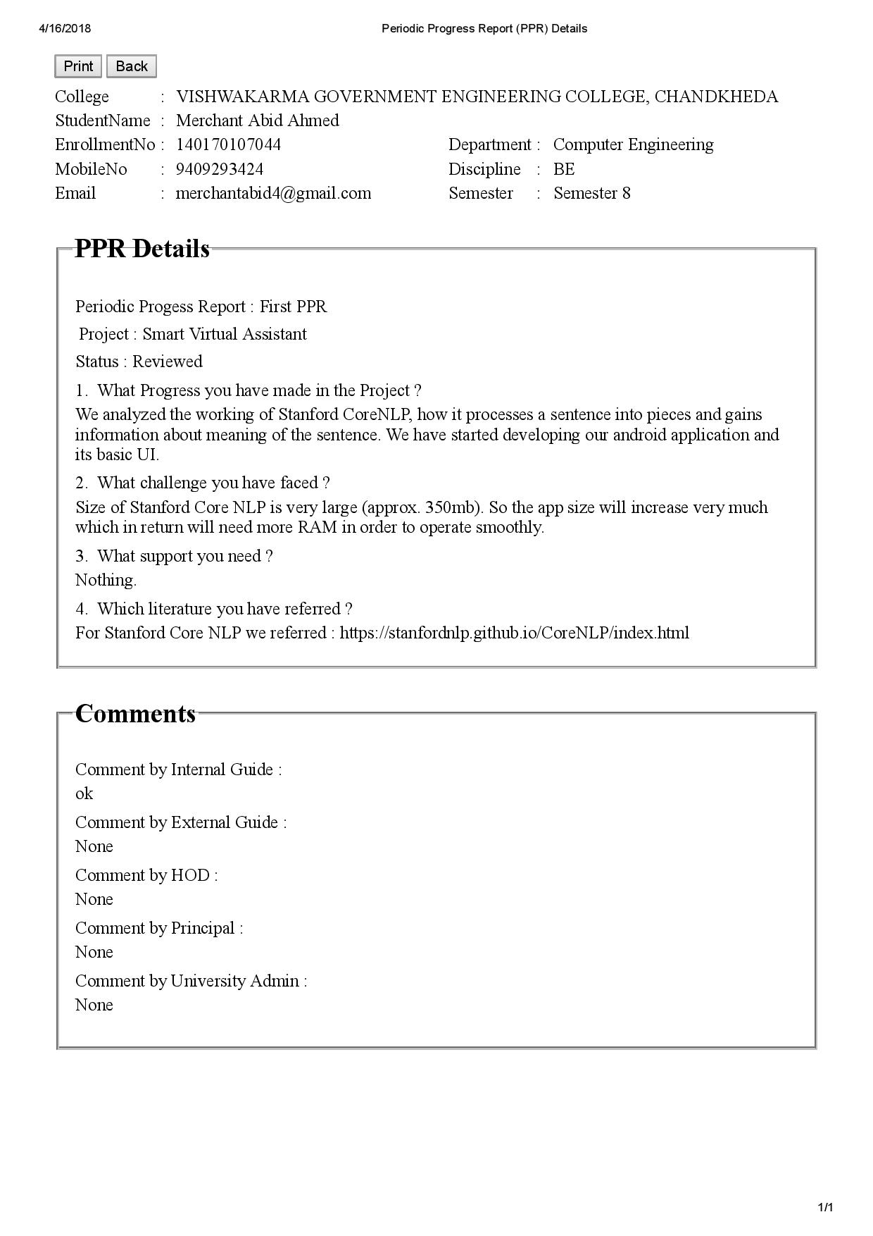

**PPR2(044)**

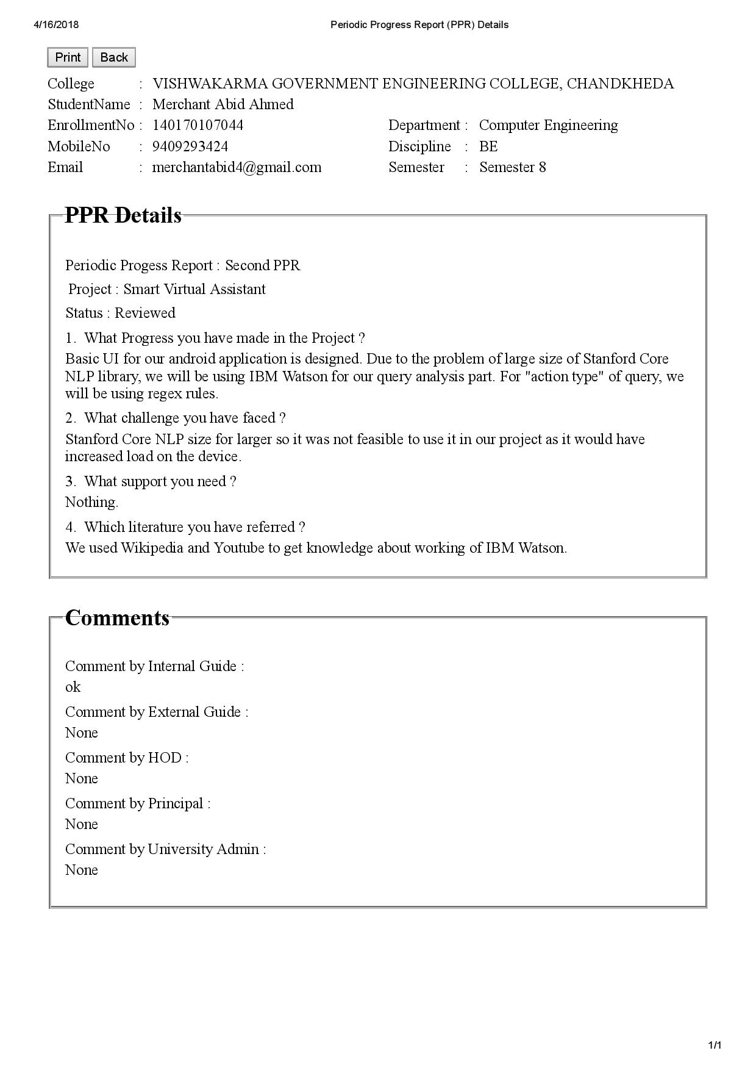

**PPR3(044)**

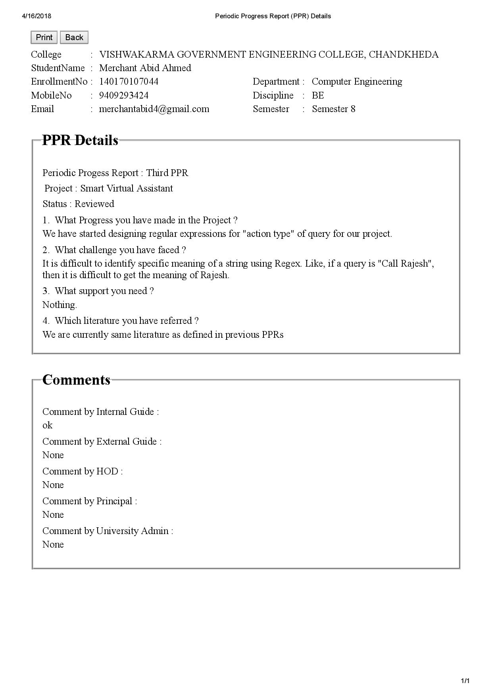

**PPR4(044)**

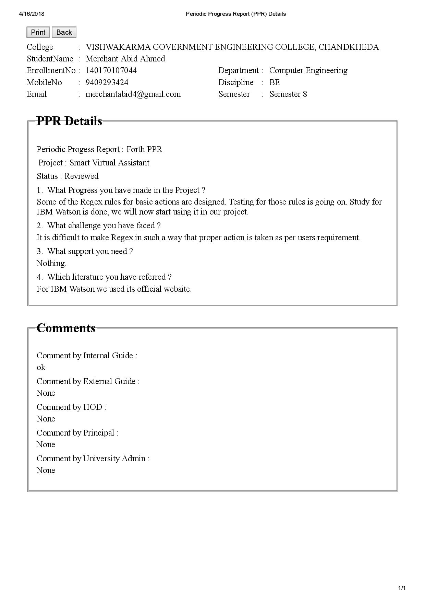

**PPR1(031)**

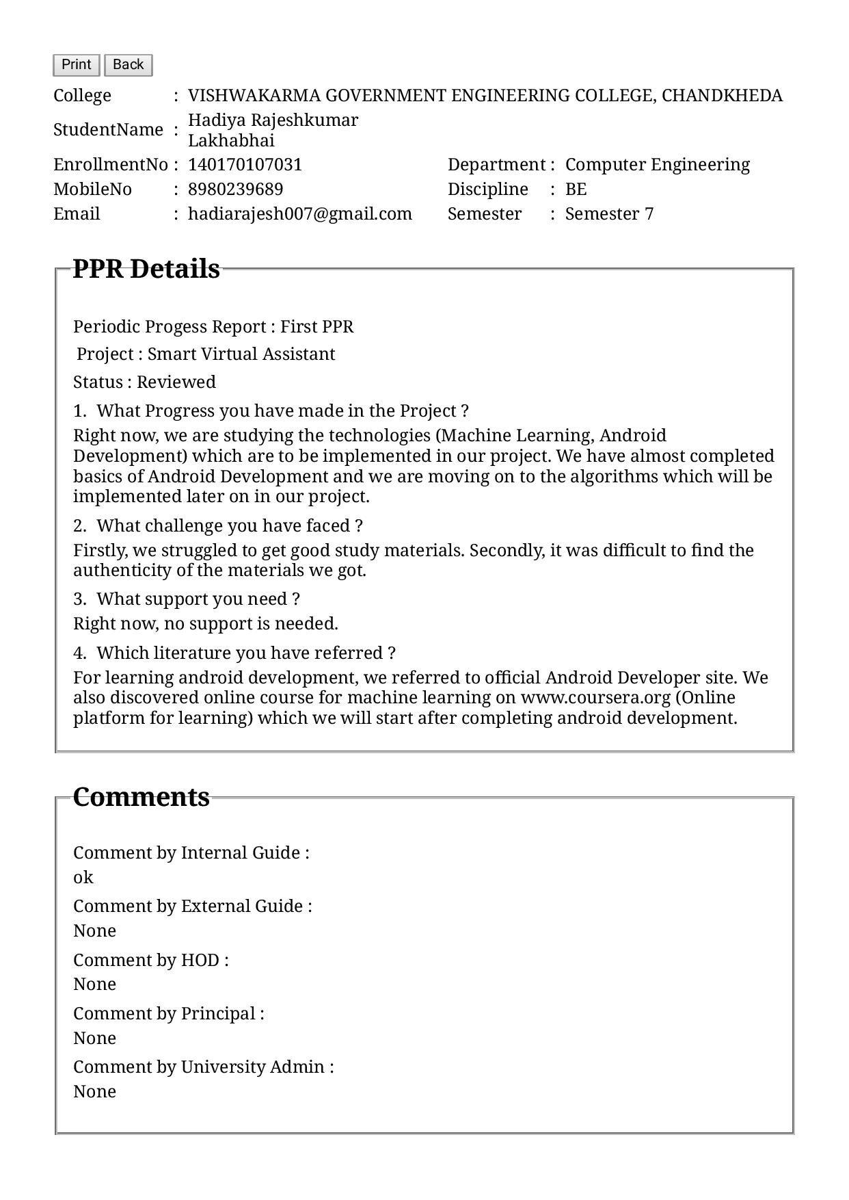

**PPR2(031)**

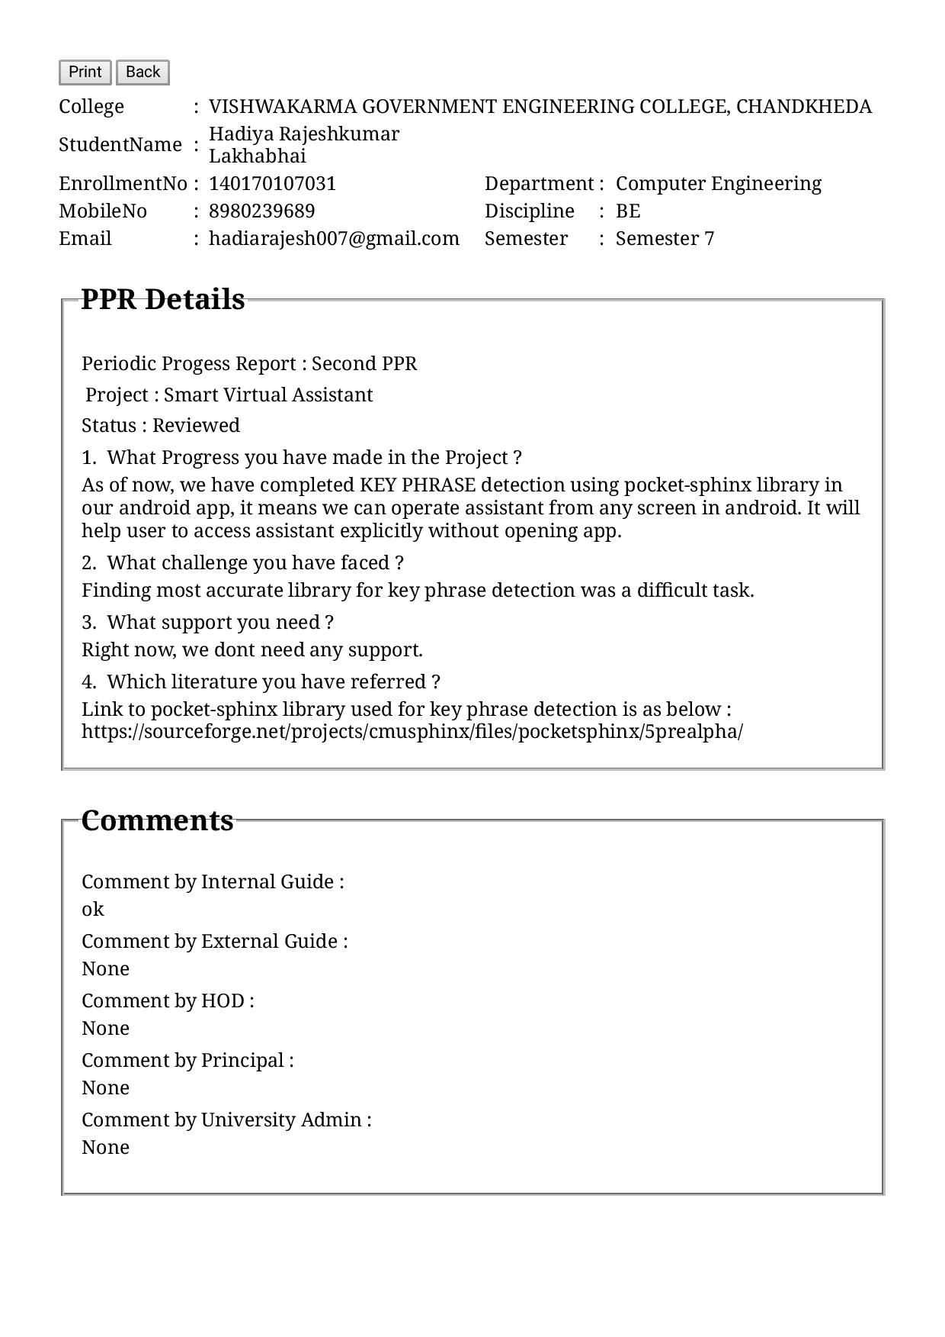

**PPR3(031)**

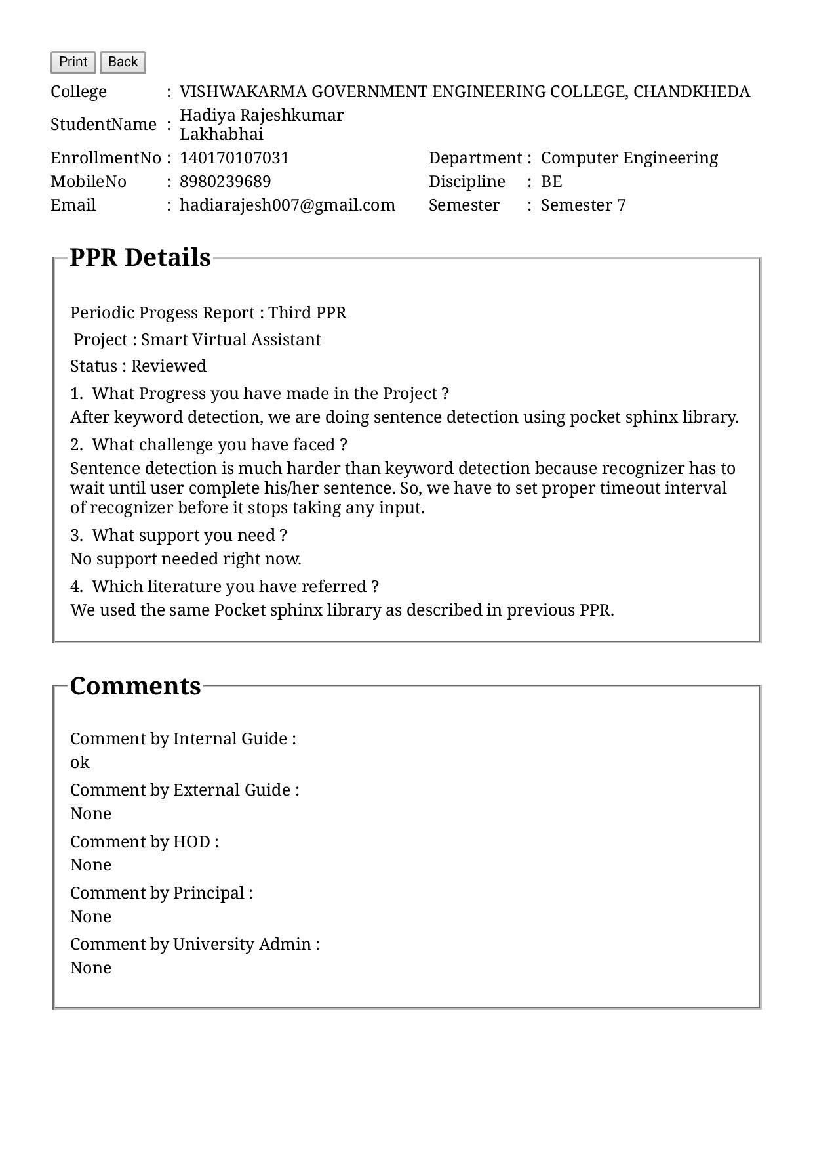

**PPR4(031)**

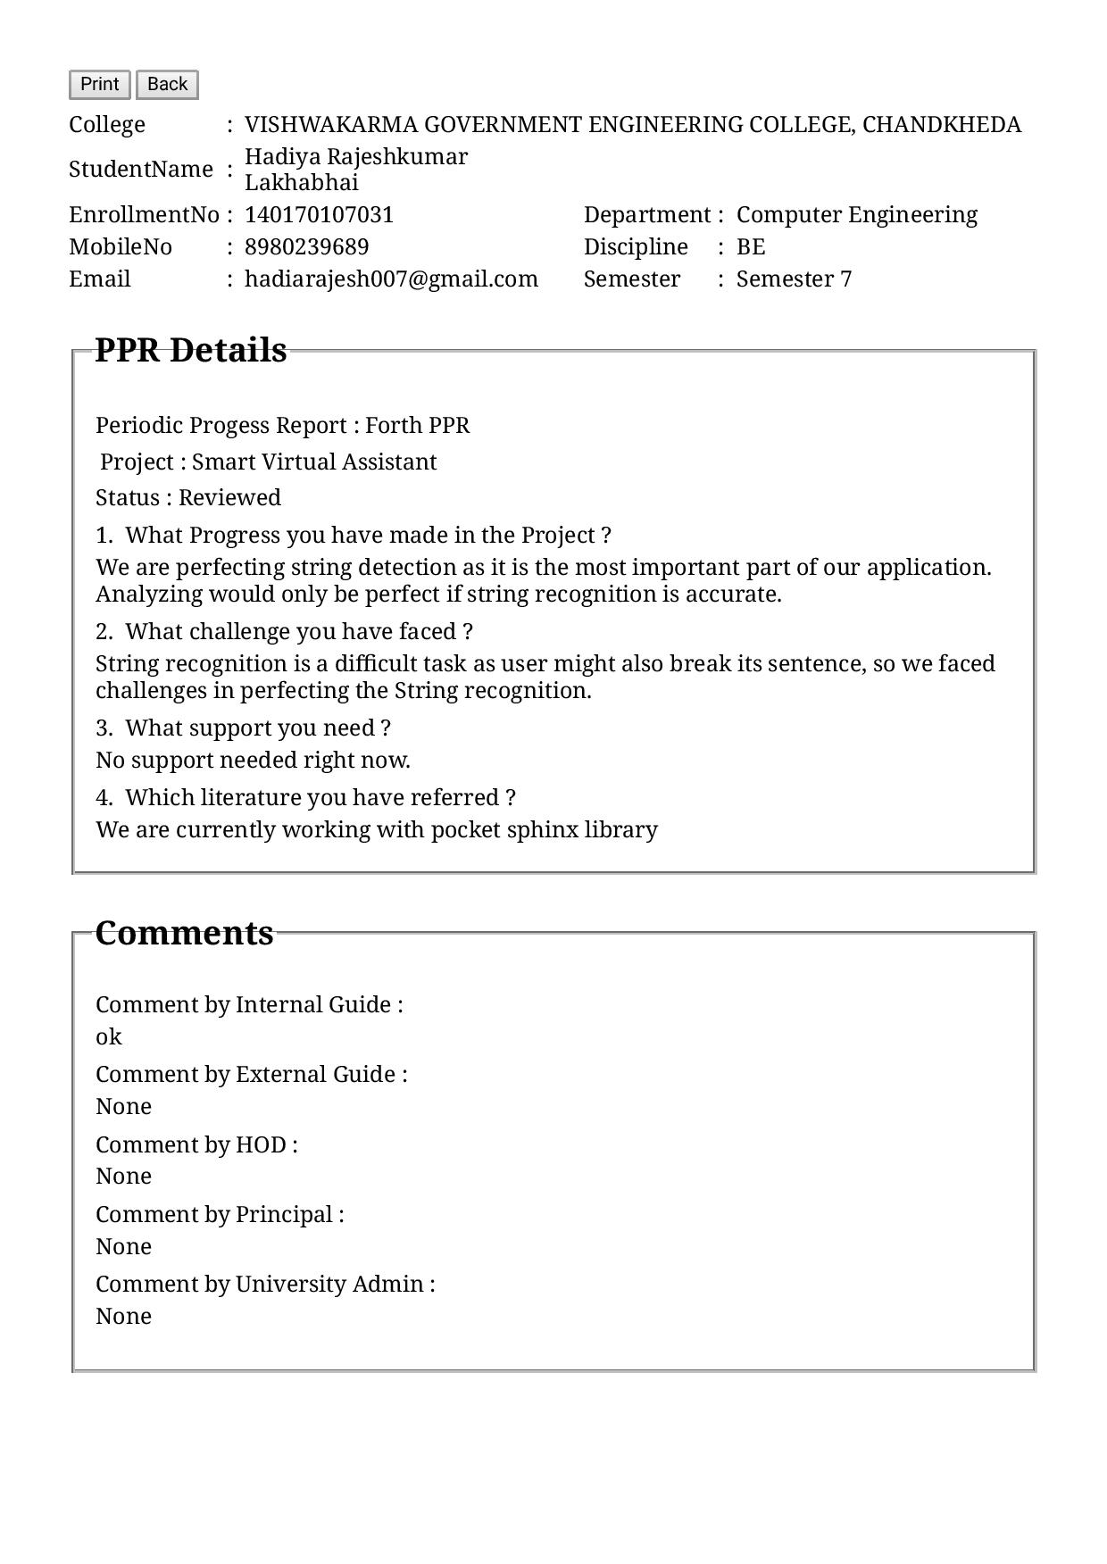

**PPR1(041)**

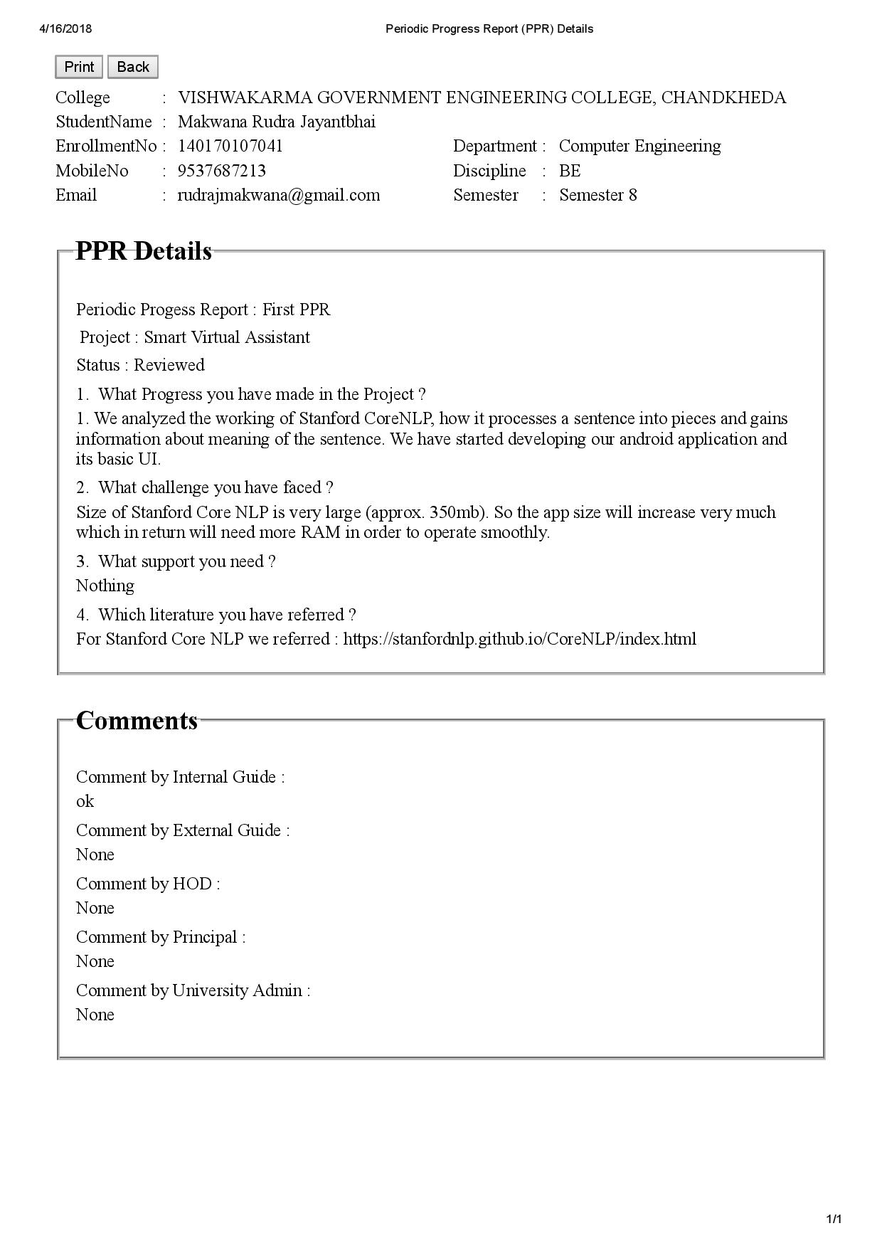

**PPR2(041)**

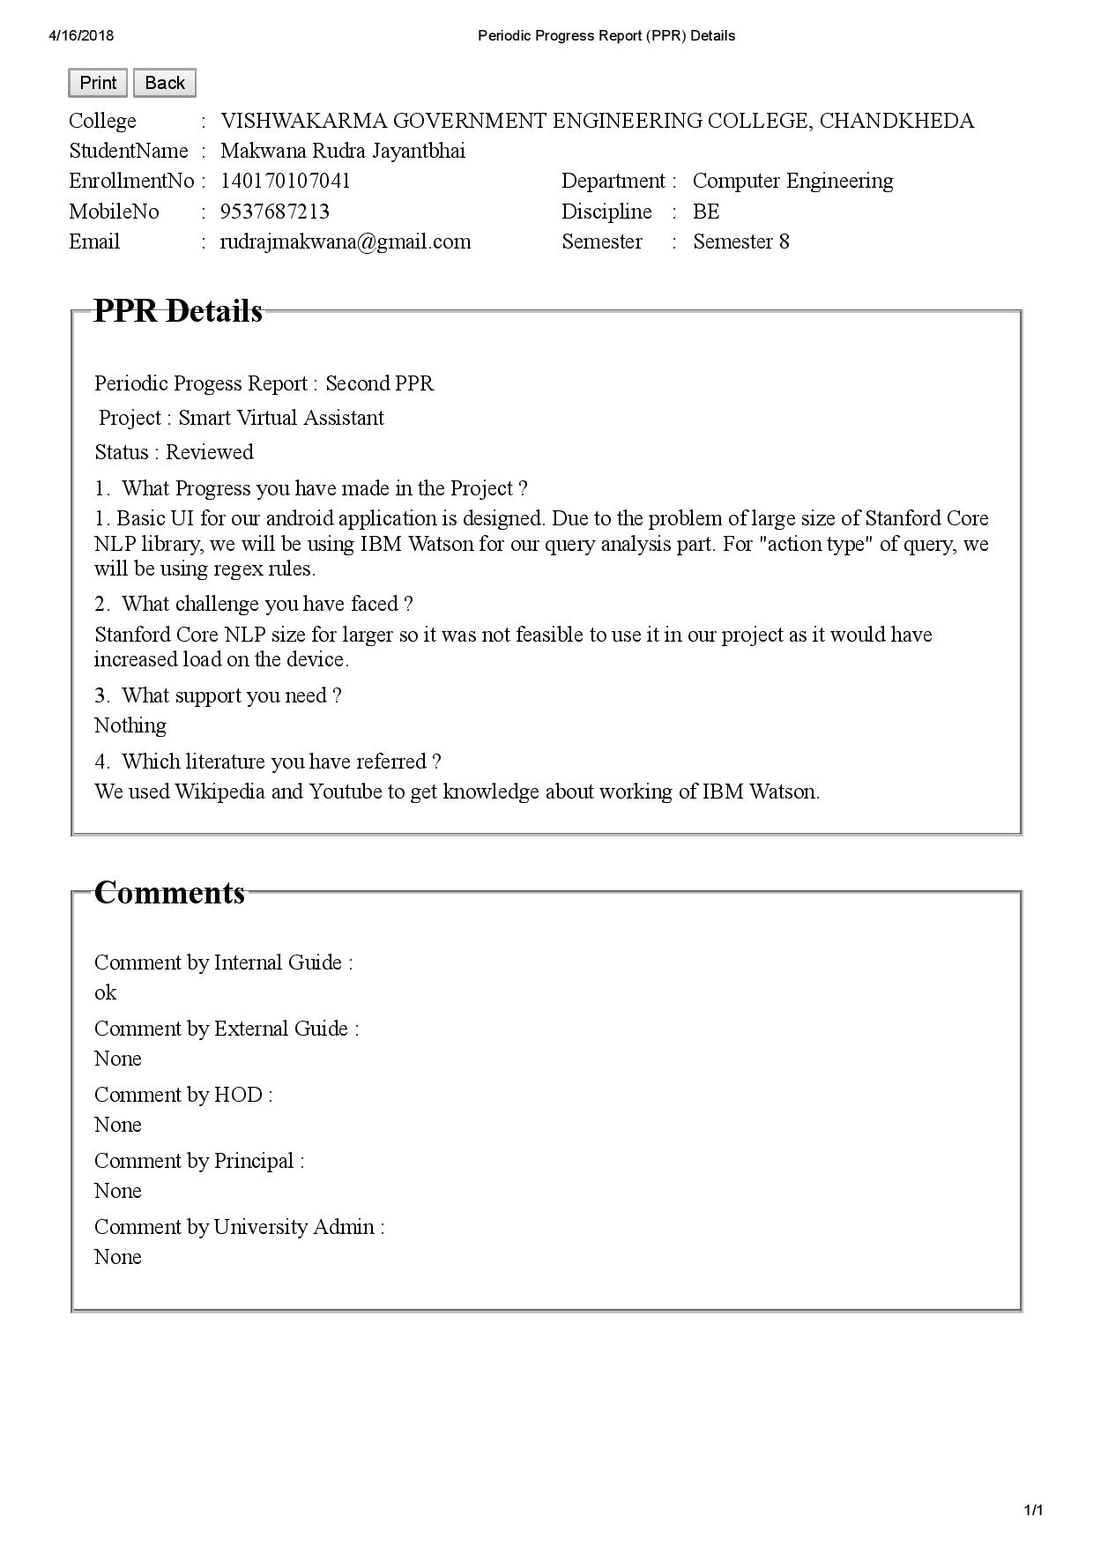

**PPR3(041)**

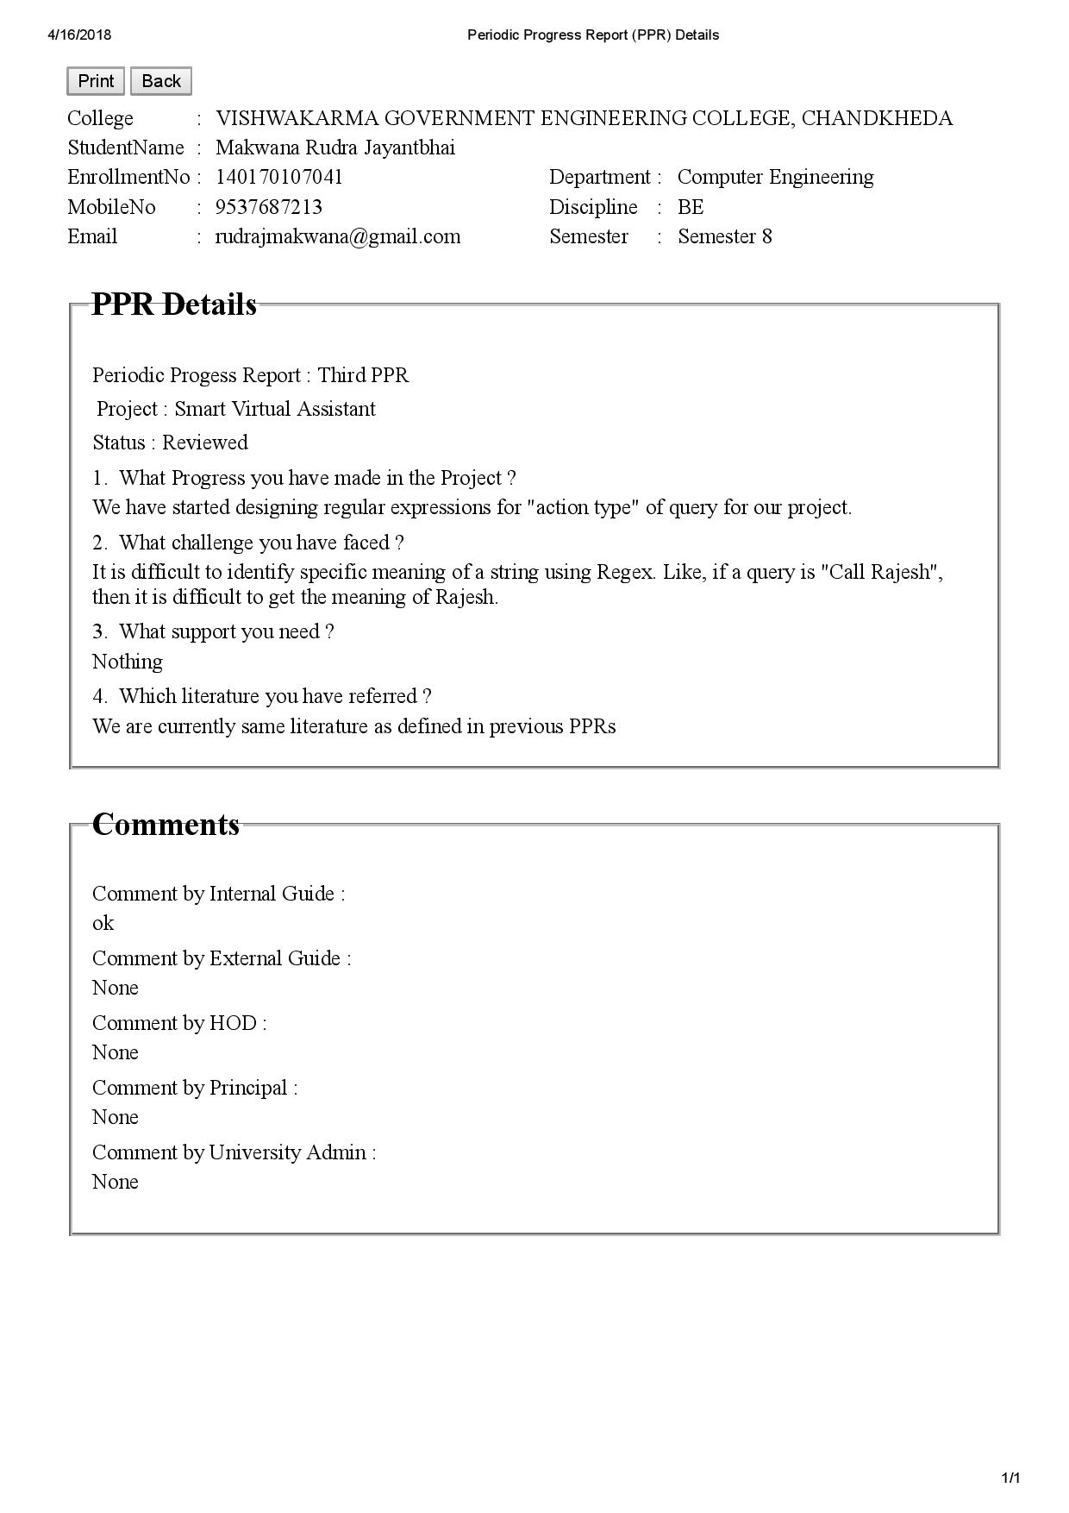

**PPR4(041)**

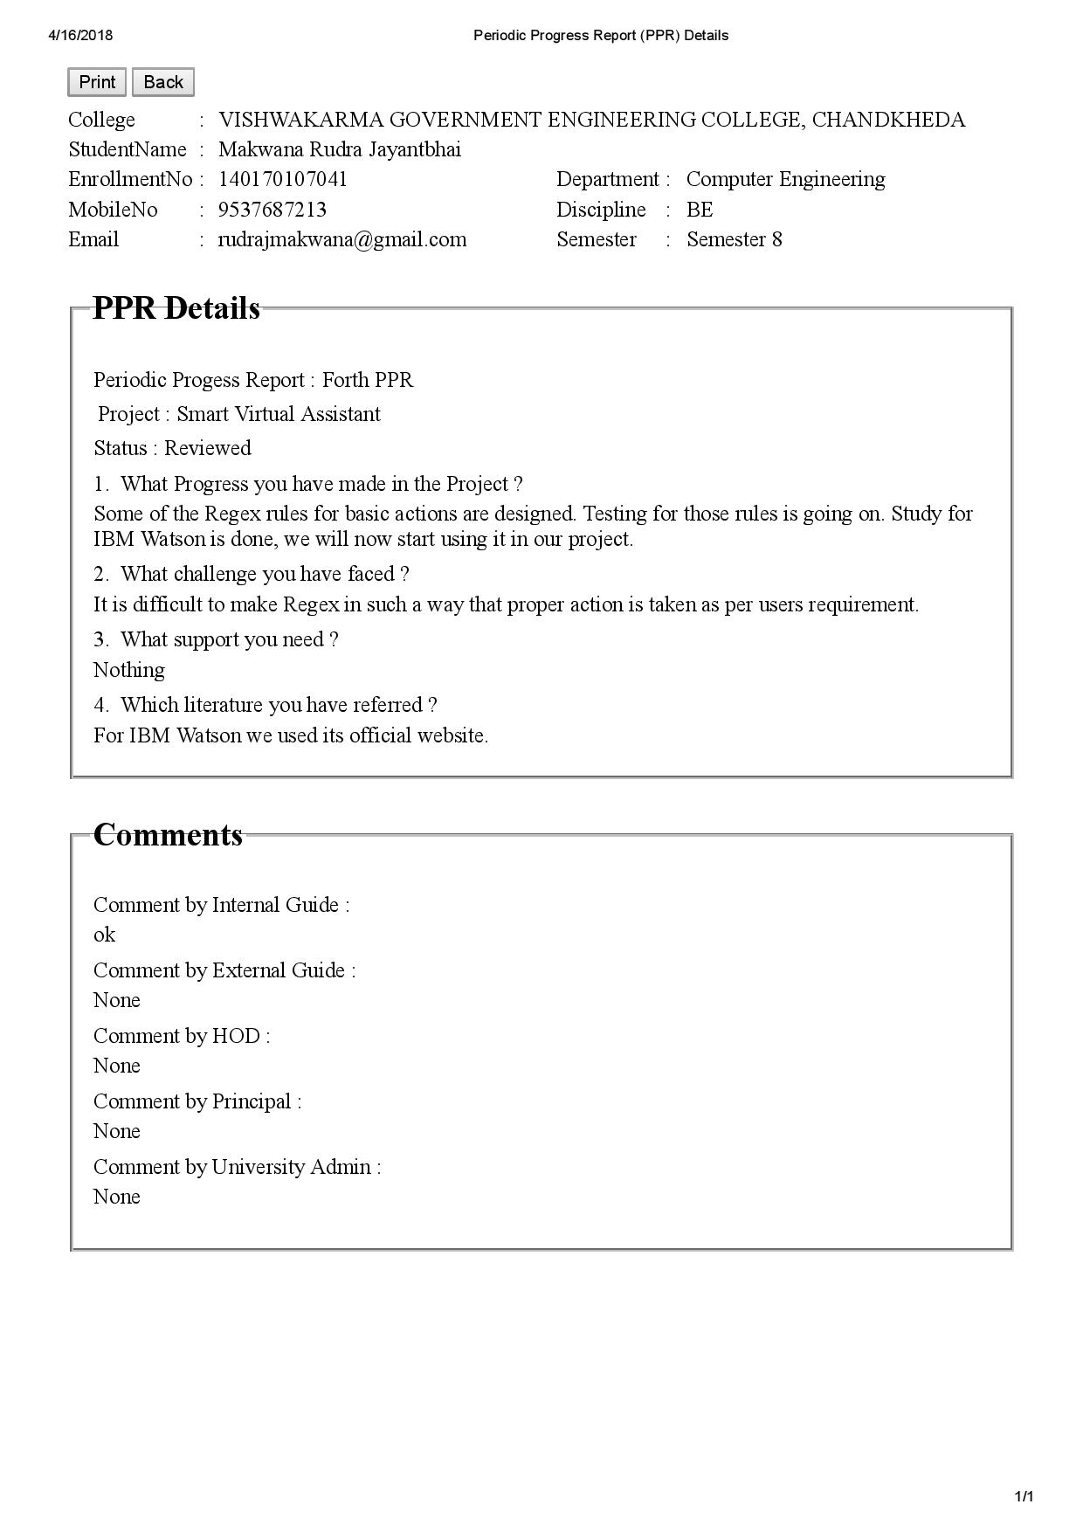

**Business Canvas Model**

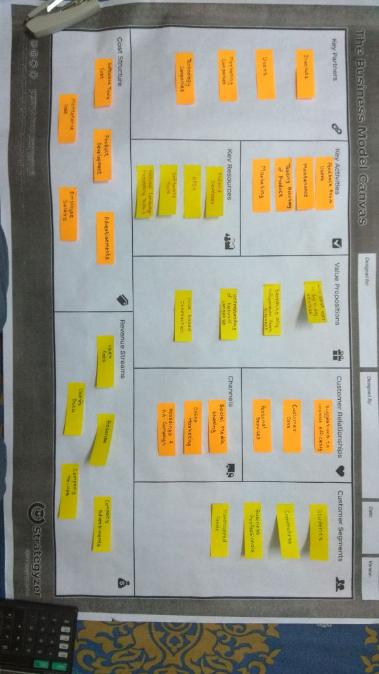

**Patent Drafting Exercise**

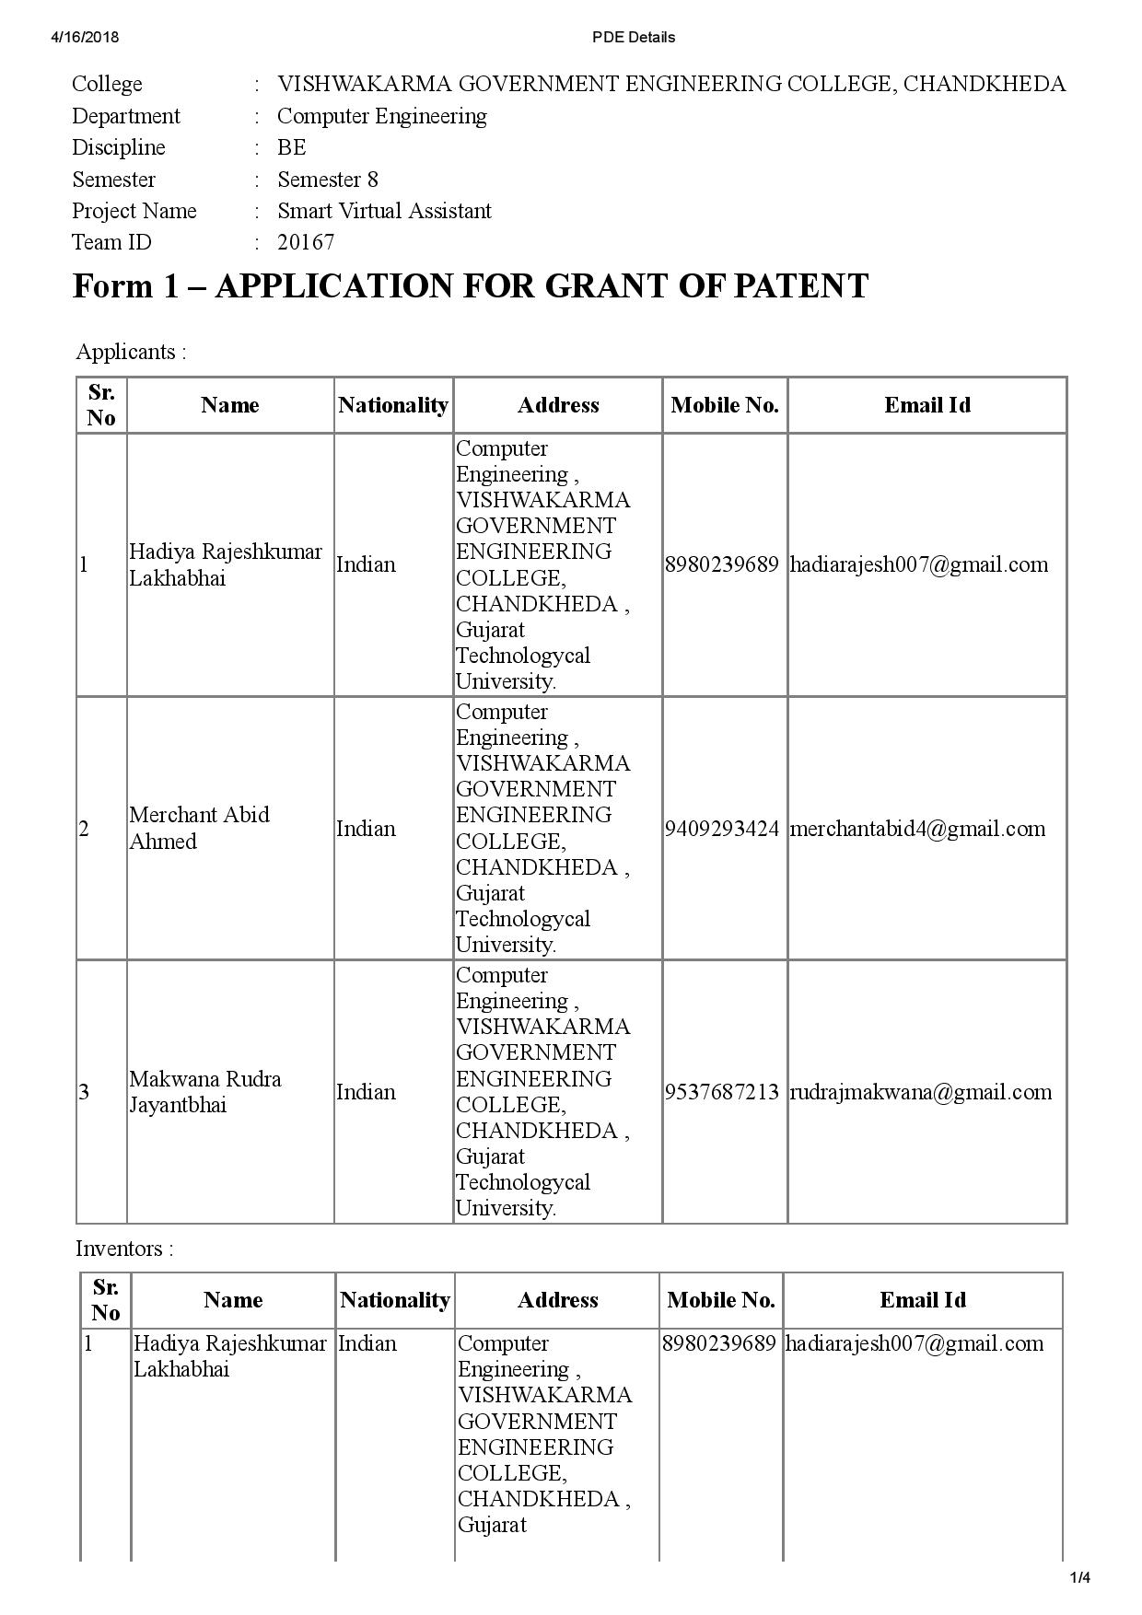

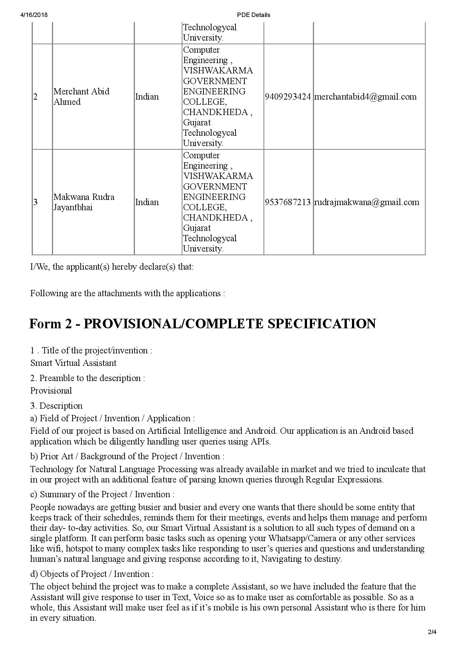

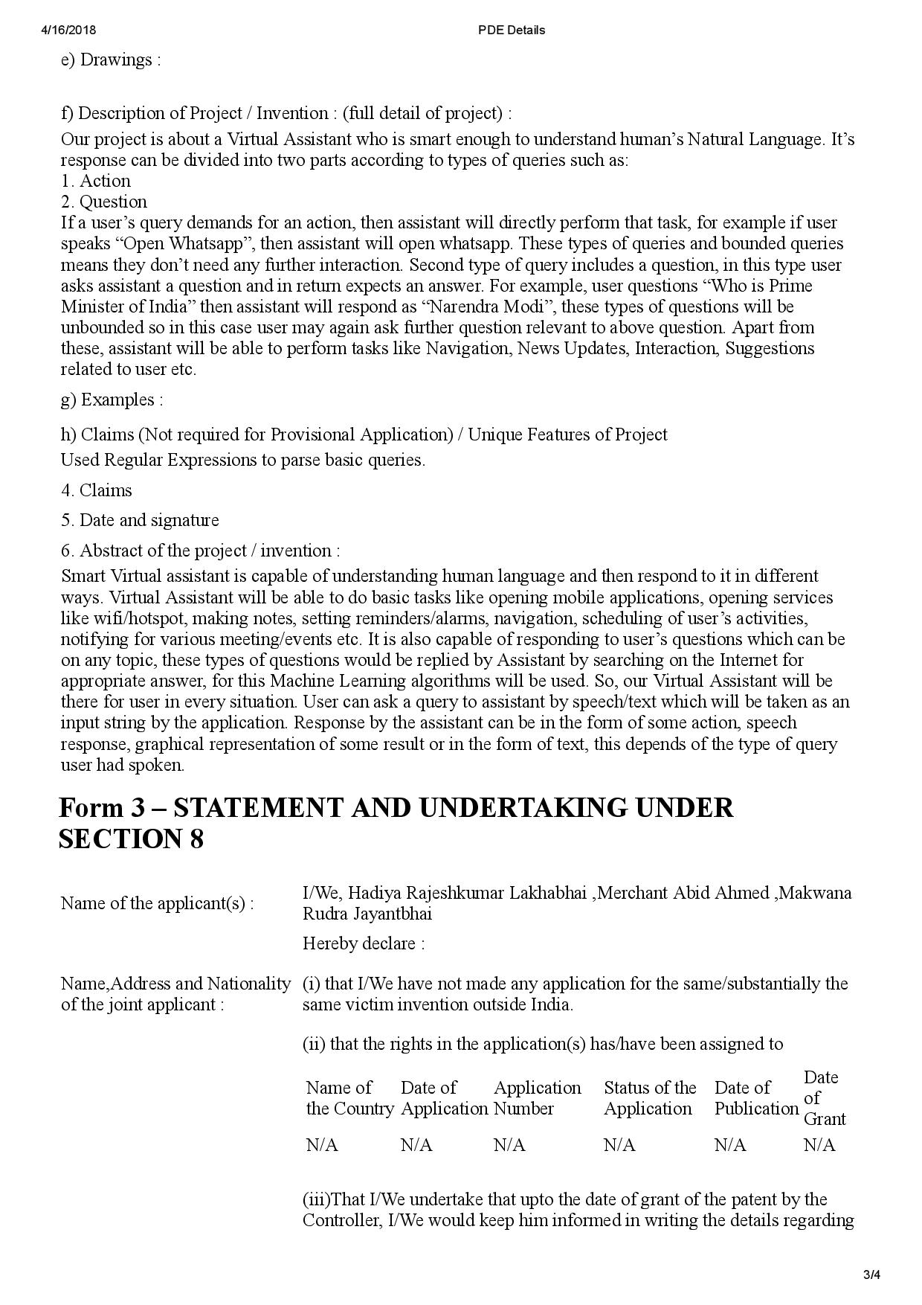

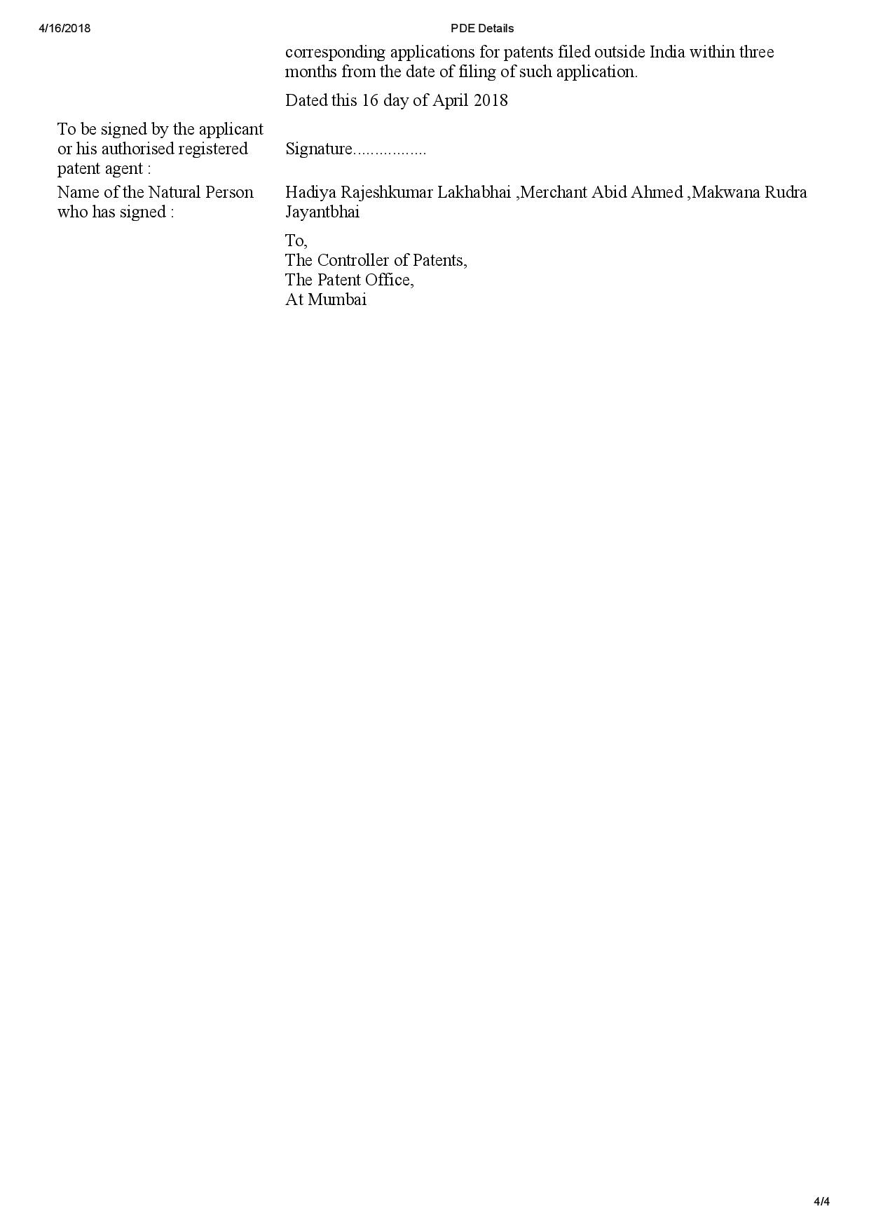

**Novelty Search Report**

**Project Empathy**

|  |  |  |
| --- | --- | --- |
| **Inventor Name(s)** | **1. Hadiya Rajesh Lakhabhai** | **2. Makwana Rudra Jayantbhai** |
| **3. Merchant Abid Ahmed** | **4.** |
| **Applicant Name(s)** | **1. Hadiya Rajesh Lakhabhai** | **2. Makwana Rudra Jayantbhai** |
| **3. Merchant Abid Ahmed** | **4.** |
| **College Name** | **Vishwakarma Government Engineering College** | |
| **Technological Area** | **A.I.** | |
| **Technological Domain** | **1. AI** | |
| **2. Android** | |
| **Technological Sub Domain** | **1. Regular Expressions** | |
| **2.** | |
| **3.** | |
| **IPC classification No.** | **1.** | **2.** |
| **3.** | **4.** |
| **Proposed Title** | **1. Smart Virtual Assistant** | |
| **2.** | |
| **3.** | |
| **Key Objective** | **1. To assist user in his/her activities** | |
| **2. To search information on internet** | |
| **3. Speech based interaction between user and mobile** | |

**Keyword Identification**

Mention keyword relevant to your area of research with their synonyms/related words

|  |  |  |
| --- | --- | --- |
| **Sr. No.** | **Key word** | **Synonyms/related words** |
| **1** | **Natural Language Processing** | **NLP** |
| **2** | **Artificial Intelligence** | **AI, ML, Machine Learning** |
| **3** | **Android Studio** | **Android Development** |
| **4** | **Regular Expressions** | **Regex, Regex rules** |

**Prior art search result in patent databases**

Generate search query using suitable operators. (**Operators**: AND, OR, NOT)

Mention the no. of Hits on came out during searching process

| **S.N.** | **Search Query** | ***Example***: ((led **OR** "light emitting diode") **AND**display**NOT** LCD) | **IPO** | **Espeacenet** | **PatentScope** | **PatSeer** |
| --- | --- | --- | --- | --- | --- | --- |
| **1** | **("Virtual Assistant" AND Mobile NOT (PC OR Computer))** | | **0** | **1** | **1** | **-** |
| **2** | **("Virtual Assistant" AND Mobile)** | | **13** | **1** | **2** | **-** |
| **3** | **Virtual Assistant AND Android** | | **12** | **0** | **2** | **-** |
| **4** |  | |  |  |  |  |
| **5** |  | |  |  |  |  |
| **6** |  | |  |  |  |  |
| **7** |  | |  |  |  |  |
| **8** |  | |  |  |  |  |
| **9** |  | |  |  |  |  |
| **10** |  | |  |  |  |  |
| **11** |  | |  |  |  |  |
| **12** |  | |  |  |  |  |
| **13** |  | |  |  |  |  |

**Important prior art details**

Mention the detail of important prior art results which is relevant to your research

|  |  |  |  |
| --- | --- | --- | --- |
| **Sr.No.** | **Title** | **Application No.** | **Priority date** |
| **1** | **Virtual Assistant** | 11/206829 | 08/19/2005 |
| **2** | **Personal Virtual Assistant** | PCT/US2001/006883 | 03/05/2001 |
| **3** | **System and methods for delivering advanced natural language interaction applications** | US13565790 | 04/10/2012 |
| **4** |  |  |  |
| **5** |  |  |  |
| **6** |  |  |  |
| **7** |  |  |  |
| **8** |  |  |  |
| **9** |  |  |  |
| **10** |  |  |  |

**Closest Prior art**

|  |  |  |  |  |
| --- | --- | --- | --- | --- |
| **Sr. No.** | **Application No.** | **Summary of Invention** | **% similarity** | **Novelty point** |
| **1** | 11/206829 | A first illustrative embodiment may be directed to a system having an information sources software module for receiving data from a plurality of information providers. Thesystem may also include a user interfaces software module for receiving input from and providing output to a plurality of heterogeneous user devices. A user data module  may store data about a specific user, where the data about the specific user includes calendar appointment information, contact information, rules information, andpreferences information. A functionality module may control overall operation of the system, and may include sub-modules such as a rules engine for analyzing and executingrules based on the rules information, and a real-time communication component. The real-time communication component may direct an incoming communication to theuser. The routing may be determined at least in part based on a recognized contact status as determined by a comparison of a call identifier with the contact information, andoptionally at least in part based on information received from one or more of the plurality of information providers via the information sources software module. | **>90%** | Real time communication component |
| **2** | PCT/US2001/006883 | The present invention relates to a personal virtual assistant with many discrete features, each of which comprises a separate but related invention. Thus, one aspect of thepresent invention is a computer-based virtual assistant the behavior of which can be changed by the user, comprising a voice user interface for inputting information into andreceiving information from the virtual assistant by speech, a communications network, a virtual assistant application running on a remote computer, the remote computerbeing electronically coupled to the user interface via the communications network, wherein the behavior of the virtual assistant changes responsive to user input. | **71-90%** | User can change behavior of the assistant |
| **3** | US13565790 | The inventor has used various systems and methods for delivering advanced natural language interaction applications, where natural language interaction engine interpretsthe request using a plurality of language recognition rules stored in the solution data repository, and based at least determined semantic meaning or user intent, the naturallanguage interaction engine forms an appropriate response and delivers the response to the user via the dialog module, or takes an appropriate action based on the request. | **71-90%** | Methods for Advanced NLP |

|  |  |
| --- | --- |
| **Comparative Novelty Analysis** | **Patentability check Report**  Please tick (√) in below field. |
| |  |  |  | | --- | --- | --- | | **S.N.** | **Prior art Features** | **Novelty features** | | 1. | Interaction with Device | User can change behaviour | | 2. | Opening Services | Real time communication component | | 3. | Starting Apps |  | | 4. | Communication with mobile |  | | 5. | Voice based Interaction |  | | |  |  |  |  |  |  | | --- | --- | --- | --- | --- | --- | | **S.**  **N.** | **Patentability Criteria** | **Low** | **Medium** | **Higher** | **Highest** | | **1** | Novelty |  |  |  |  | | **2** | Non-obviousness |  |  |  |  | | **3** | Industrial Applicability |  |  |  |  | | **4** | Sec 3d - Pharmaceutical |  |  |  |  | | **5** | (sec.3f) -Mere rearrangement |  |  |  |  | | **6** | (sec 3k) - Software invention |  |  |  |  | |